AMB 300
Legacy Community Connect
Epic Hyperdrive 2026

WHA OB/GYN PROVIDER TRAINING

AMB 300 Table of Contents

Contents
Module 1: Signing in to Epic 4
Exercise 1: Open the Citrix Receiver 4
Exercise 2: Log into Hyperspace 5
Module 2: Basic Navigation and Functionality of Epic 6
Exercise 1: Physician Dashboard 7
Exercise 2: Hyperspace Toolbar 9
Exercise 3: Navigate to the other Workspace Tabs 11
Exercise 4: Multiple Provider Schedule 12
Module 3: Gynecologic Clinical Workflows 19
Exercise 1: Chart Review – Getting up to speed on your patient 19
Exercise 2: Quick Visit Documentation 25
Exercise 3: Pre-Charting – EST WELLNESS VISIT – ANNUAL 42
Module 4: Use the Card Viewer 44
Exercise 1: Respond to Patient Call 44
Module 5: Clinic Visits/Procedure Workflows 47
Exercise 1: EST WELLNESS VISIT – ANNUAL 47
Exercise 2: Procedure Visit – Colposcopy 53
Exercise 3: GYN Telehealth Visit 60
Module 6: Obstetric Clinical Workflows 69
Exercise 1: New OB Workup 69
Exercise 2: Return Prenatal Visit / NST Documentation 86
Exercise 3: Postpartum Telehealth Visit 95
Exercise 4: PP8/Wellness Exam and IUD Visit Documentation 98
Module 7: IN BASKET Workflows 105
Exercise 1: Access the In Basket Activity 105
Exercise 2: In Basket Functionality Demo. 106
Exercise 3: Create Staff Message 112
Exercise 4: Rx Request Folder/ Rx Refill Encounter 113
Exercise 5: Rx Request Folder/ Rx Refill Encounter 115
Exercise 6: Results Folder 118
Exercise 7: Results Folder 122
Exercise 8: Results Folder 124
Exercise 9: Respond to Patient Call 125
Exercise 10: Respond to Patient Call 127
Exercise 11: Attach to Another User’s In Basket 129
Module 8: Wrap Up 133
Q& A 133
Where to find Legacy Resources 133
Tip sheets 133

Module 1: Signing in to Epic

Exercise 1: Open the Citrix Receiver

Objective: To show learners how to access and login to the Epic Training system.
We will now log into the system and get started for the day.
In the clinic, you will click on the Legacy Apps icon on the desktop:

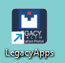 - This is the default access to the system.

- Double-click the Legacy Apps icon.
- Then click Hyperspace ACE 1.
- Log in using the Fremont log-in located at the bottom left of your computer screen.

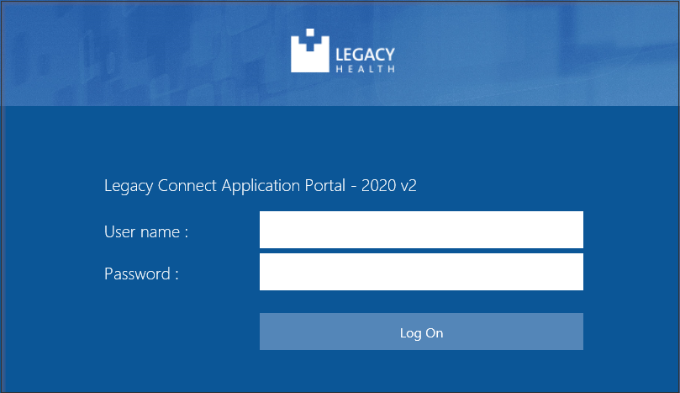

Exercise 2: Log into Hyperspace

Objective: To show learners how to understand and locate information specific for training class.

Direct each learner to their Tent Card. Point out the User ID, Password, Departments, Patients and Providers.

- Then select the correct EPIC ACE 1.

Login with your Tent Card information:
- User ID: WHAMD##
- Password: train
- Login Department: WHA TUALATIN [400147012]
- Message tip of the day; Click Ok

Module 2: Basic Navigation and Functionality of Epic
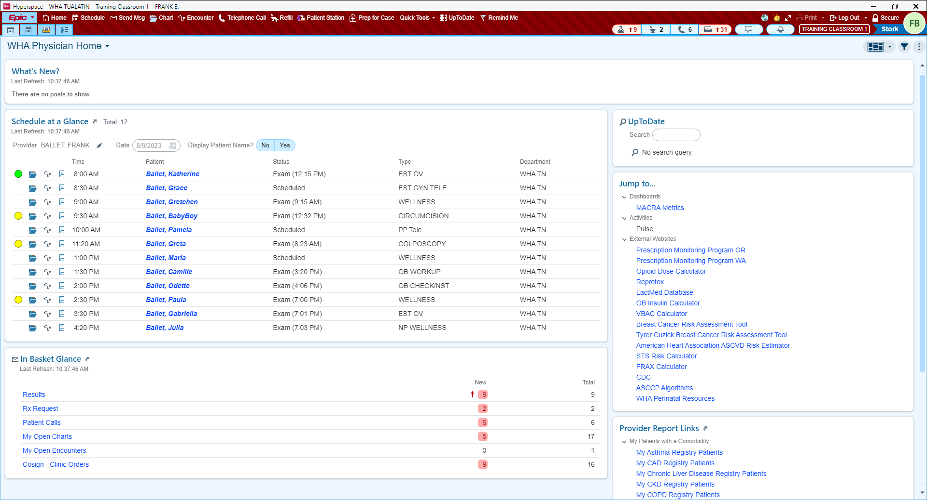

Exercise 1: Physician Dashboard

Objective: this window is your current default when you first login to Epic and highlight different sections.

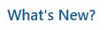
NEWS: If there is any high-level news that needs to be shared with our Epic using Ambulatory Providers you can find it here. Example: e prescribing interface functionality down.

Schedule Glance: Quick glance at your scheduled patients for the day. If you click a patient’s name it opens their encounter.
Open Encounter
Open Chart

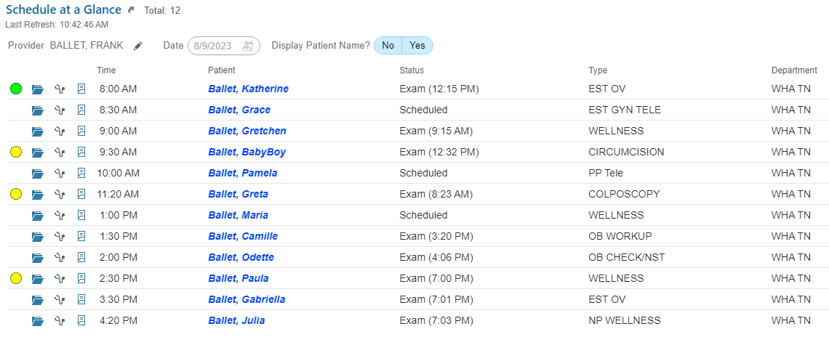

In Basket at a Glance: Quick glance at messages “tasks” in your In Basket.

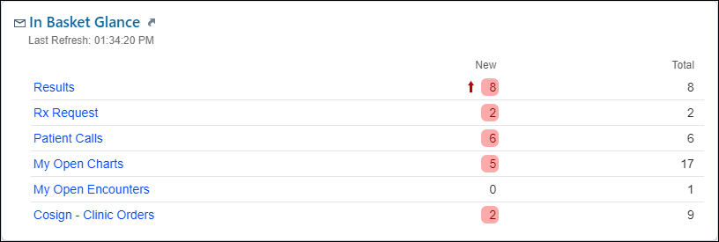

UP TO DATE 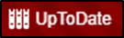: is also available on your Hyperspace Tool Bar.
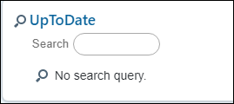
Clinic ref tools: guideline links for Dx/Tx, what’s new in practice changes all while earning CME credits.

Jump to: Dashboards, Activities, and External website links such as Prescription Monitoring Program, Calculators, Assessment Tools, CDC, algorithms, WHA Perinatal Resources and more.
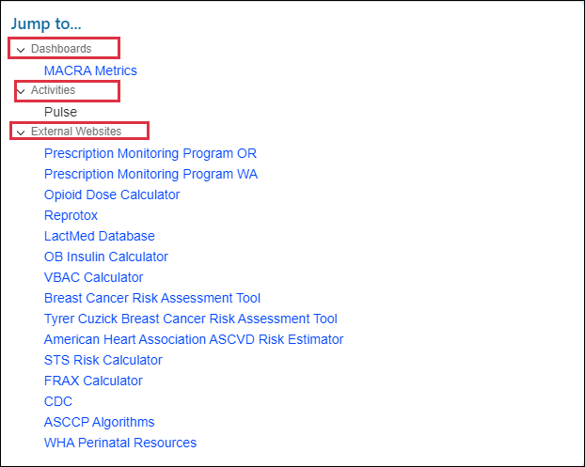
Provider Report Links: to reporting workbench reports that clinicians may use for patient care.
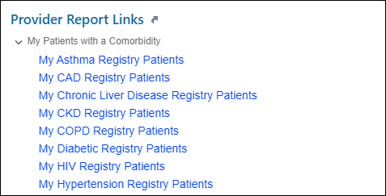

Exercise 2: Hyperspace Toolbar

Objective: To have learner comfortable with navigation and accessing specific activities.

These are common activities for your job role, available for quick access.
Epic button: Located on far left of the hyperspace toolbar. It contains your favorites, recent activities and less frequently used features. This is a lot like your All Programs button on your computer at home minus solitaire.
Home: Takes you to your default home screen.
Schedule: Takes you to the Multi Provider Schedule activity.
Chart: To open and review a patient’s chart.
Encounter: To open an encounter for a patient not on your schedule or for a selected patient.
Quick Tools: Contains commonly used tools under one activity. Managers, Smart phrase, lists, and sets, list composer, dictionaries and more that you will learn more about in training.
UpToDate: Clinical Decision Support which takes you to the log in page.
RemindMe: To create Reminder messages for work to be done. We will explore this later in training.

There are some activities we will explore throughout the class, and others on this menu you may never use in your job role. 

The toolbar is customizable. You can arrange your hyperspace bar by dragging and dropping activities to a different location. Remove activities you do not use by right clicking on the activity and click remove.
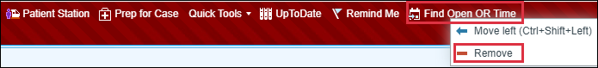
To add activities to the Hyperspace Bar:
- From the Epic menu > OB Tools > Pregnancy Wheel.

Log Out button: Logs you completely out of Epic. Use for breaks, lunch, or leaving for the day.
Secure button: Looks like a padlock. It prevents unauthorized access to the record (patients in unattended exam room). Also bookmarks the screen to open when signing back in. Secure is used whenever you leave the exam room, or whenever you leave your workstation.

Exercise 3: Navigate to the other Workspace Tabs

Objective: Discuss how to navigate around Epic and what different activities are available for different workflows.
Show how you can “hover to discover” over the workspace tabs. Please note that I will not being showing what every button does but will be focusing only on the ones that are pertinent to this training.
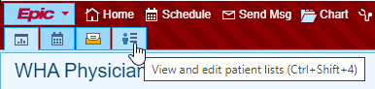
- My Dashboards: Your default Connect Physician Home dashboard. Resources available under MyLegacy Intranet Links and Physician Reference.
- Schedule: This displays daily appointment schedules for individual providers/resources or for the entire department.
- InBasket: This represents the InBasket activity, which is the communication hub for clinician tasks.
- Patient Lists: This is a way for you to keep up to speed on your hospitalized patients.
- Click the Schedule button. OR 
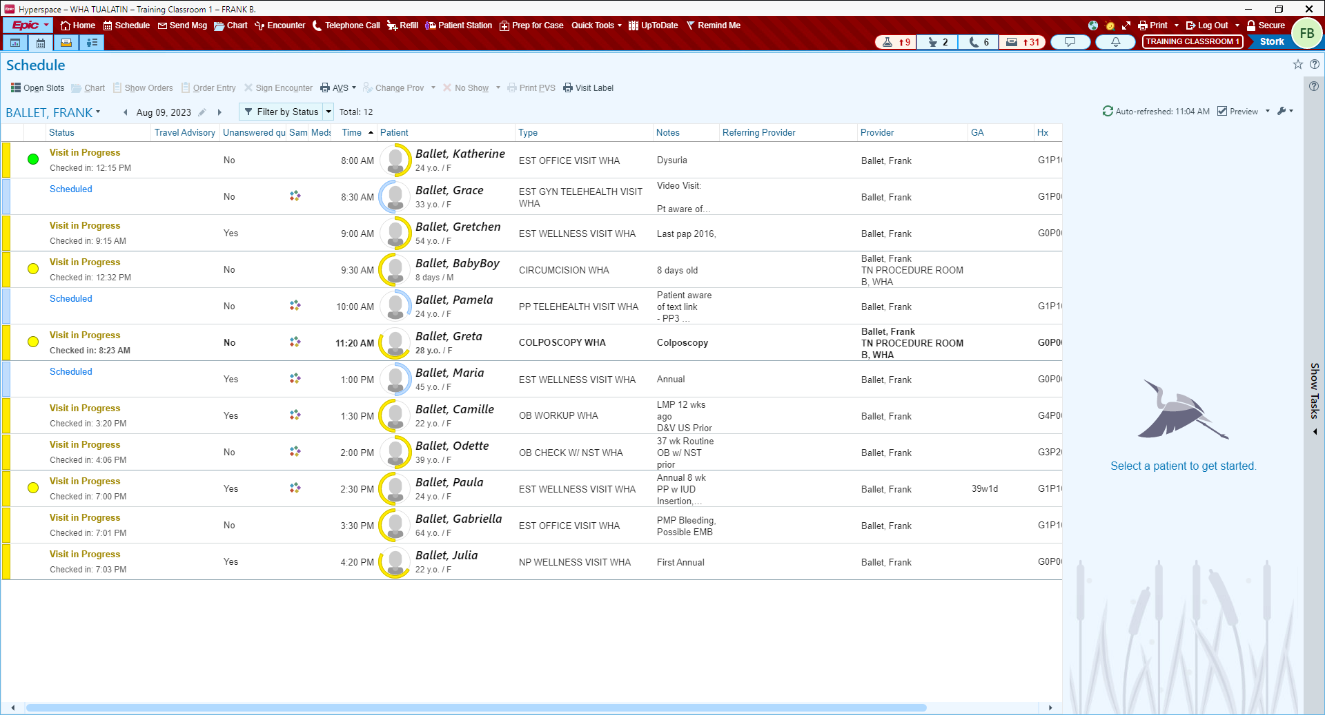

Exercise 4: Multiple Provider Schedule

Objective: To have learner understand basic navigation and accessing specific activities.
Now we will explore the Provider Schedule window.
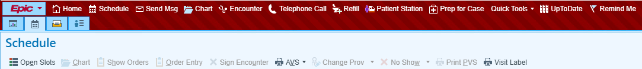
Activity buttons: specific to the activity or window currently viewing.
(Chart 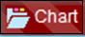on main toolbar vs Chart in the Schedule activity.)
- Chart on Main toolbar opens the Patient Lookup window.
    - 3, 3 Rule - type the first three letters of the patient’s last name, and then first three letters of first name.
      - Example: Wes, Katherine for Katherine West
    - First three letters of first name (space) First three letters of last name.
      - Example: Katherine West
    - Phone Number: Type ph. (space) and phone number to locate patients from your caller id: (Example: ph. 971-555-1234)
- Chart above calendar on Schedule activity opens Chart Review for the patient you have highlighted on your schedule.
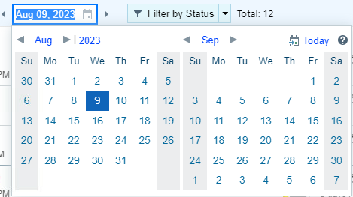
Calendar: View scheduled patients for a specific day.
Ability to select specific schedules and view other departments.

Multi-Provider Schedule
My Schedule – Frank (12 patients)

Patients with scheduled appointments will show on the right. At the top right of the schedule, you can see the total # of patients, the last time the system refreshed itself, which is every 5 minutes, and a manual refresh (the are you here yet button).
Department Folder – WHA TUALATIN 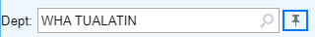
- You can change the department here to view another clinic’s schedule however, this does not change your login department
- To change your login department, click the arrow next to Log Out.

- Click the arrow next to the WHA TUALATIN folder

All providers that could work in your department are now visible.
Now you can click on any provider listed and view their scheduled patients.

Schedule Folders – 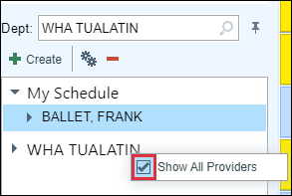
Open folder and right click on ‘WHA TUALA’ then uncheck box to see only the providers who are in office that day.

Ability to select specific schedules to view information.

Schedule appointment information section.
- Blank Column: To flag the patient’s name with colored dots. Dots are visual cues that a task is ready to be done.
- Blue dots: This happens automatically when a procedure is ordered (POCT, immunizations, clinic administered medications, labs).
- Yellow dots: This happens automatically when outpatient labs are ordered (imaging and referrals).
- Green dots: This displays when the MA/RN is finished with in person or virtually rooming the patient to signal that they are ready to be seen.
- Black dots: These are displayed when the MA/RN has not been able to contact a patient prior to their Telehealth appointment

- Status Column: Status of patient’s appointment.
- Scheduled: Patient has not checked in at the front desk.
- Present: Patient is in the building but may be busy completing paperwork, is not ready to be called back from the waiting room.
- Arrived: Patient checked in, and is ready to be called back to the exam room.
- Visit in Progress: Patient is in the room with MA or Provider.
- Waiting: A patient has been roomed and the status has been changed to Waiting by the MA/LPN/RN
- Checked Out: Patient checked out at the front desk after an appointment.
- Signed: Provider has completed documenting visit and has sent to billing.
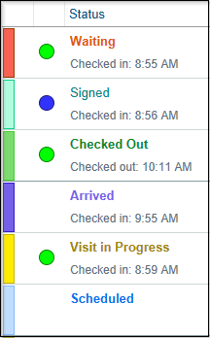
- Status: Displays the appointment status of the patient and the exam room number when MA logs into the exam room computer with the patient.
- Unanswered Questionnaires: Displays yes/no to indicate that the patient has unanswered history, series, and/or general questionnaires for an appointment.
- Same Day Visit: Displays an icon if the patient has any other appointments or cases scheduled on the same day as current visit. Hover to discover more information about these same day appointments.
- Meds Due Column: Red clock icon displays when Facility Administered Medications (FAM) are ordered. The icon hyperlinks to the MAR to document administration.
- Time: Scheduled start time of the visit.
- Patient: Preferred name displayed, with age and gender identity
- Visit Type: Scheduled Visit Type (this can drive different documentation tools)
- Notes: Why the patient is coming in to be seen.

Notifications : When you have new notifications, a dot appears to let you know, and the number of new notifications appears next to the bell. Notifications are available in the Notification Center until you change context, secure your workstation, or log out.

Report pane: located on the bottom half of your workstation
Single click the first patient to view the Report section.

OB Snapshot is the default report – Has patient current information available in one report.

“Getting to know your patient is 60 sec. or less”

Each section contains current information and allows to quickly jump into a specific area of the patient’s chart.
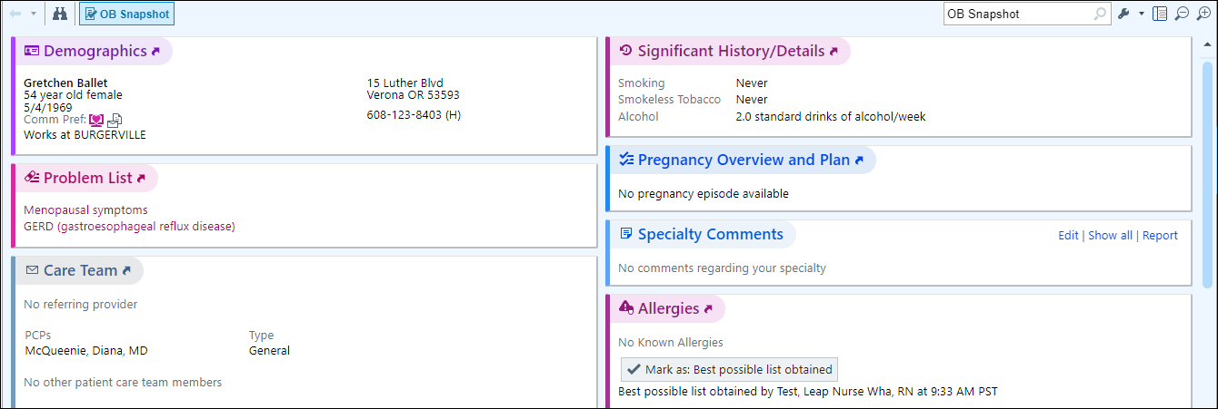
- Demographics – Patient Identifiers: Age, Sex, Address, Phone #’s, etc.
- Problem List – Patient’s current problem list.
- Care Team – View patient’s PCP and other Care Team Members
    - Examples: Social Workers, Nutritionist, and Behavioral Specialists.
- Health Maintenance – Care Gaps identified by patient’s age, sex, and documented problems.
- Vitals from last encounters – This shows vitals recorded over the last 365 days.
- Since Your Last Visit – Access Progress Notes from visits to similar specialty.
  - Saves time from having to jump into Chart Review.
- Immunizations/ Injections – Documented Immunizations
- Preferred Pharmacies – Patient’s Preferred Pharmacy information.
- Medications – Patient’s current medication list.
- Allergies – Patient’s current documented allergies.
- Specialty Comments – Place to document specialty specific information
- Significant History/Details – Tobacco and Alcohol history.

Other reports are available that you may want to reference for different patients.

To make these reports as speed buttons on the report toolbar.
- On the far-right side, click the wrench. 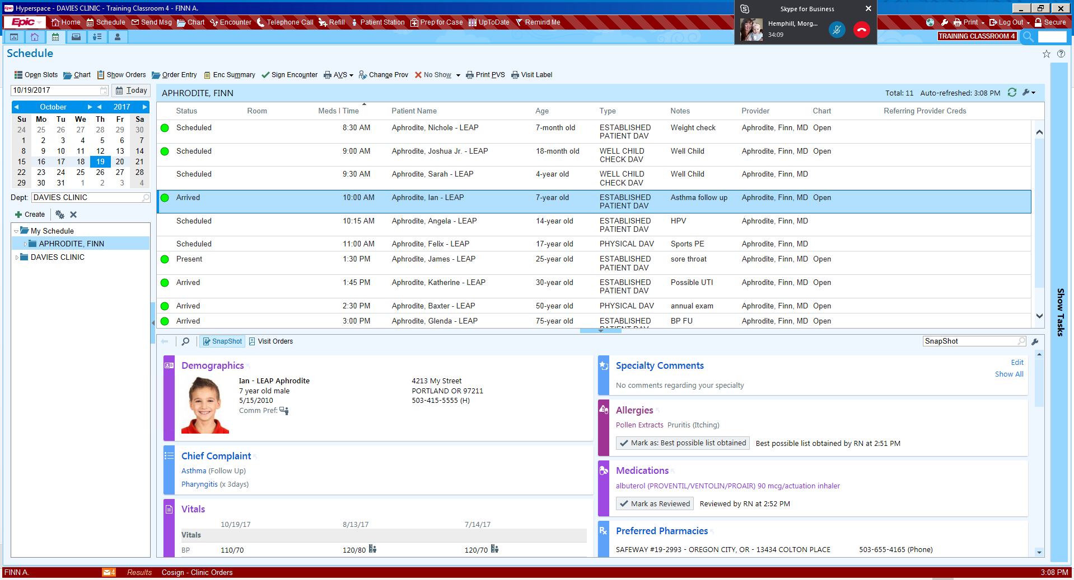
- Click Add or remove buttons from toolbar.
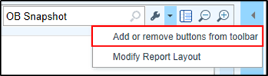

The first field has a Magnifying glass or what Epic calls a Selection Tool, this is a visual indicator that there is a list to select from. To shorten the list, type in the first part of the name of each report and press Enter to allow for quick selection.
Review the following Reports: These have been customized by clicking the wrench.

  - Snapshot-Patient – Summary of current documentation on the patient.
  - WHA Pregnancy Episode – Summary Report that is configured to include information like an ACOG report.
  - Rooming Report – Report that displays Chief Complaint, Vitals and Progress Notes that have been documented for the selected patient in today’s visit.
  - Visit Orders – Way to view all orders and results from today’s visit.
  - Visit Charges – View all charges that have been documented in today’s visit.
  - AMB Facesheet – Demographics, Insurance information, PCP number, Contact information

Card Viewer
- Click Show Tasks bar on the far right of the screen.

This is a section that allows you to view and take action on certain types of messages/“Tasks” for:

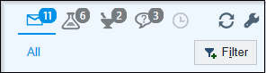

- All
- Results
- Rx Requests
- Communications such as Patient Calls “Telephone Encounters”.

- Click Return to Schedule to collapse the section.
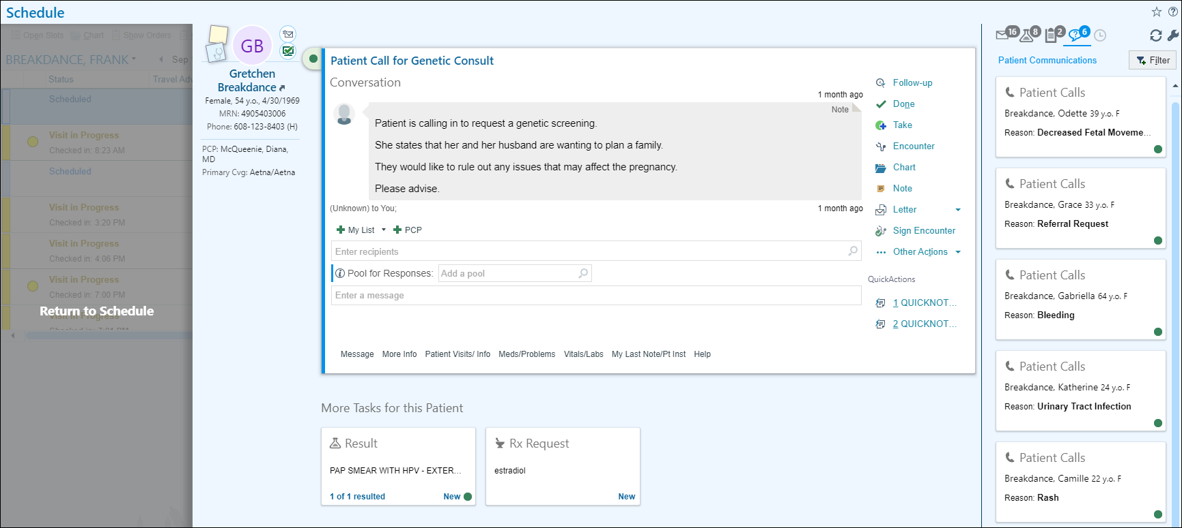

Module 3: Gynecologic Clinical Workflows

Exercise 1: Chart Review – Getting up to speed on your patient

Scenario: The Schedule shows that Katherine is Visit in Progress and waiting in the exam room. First, you will want to get up to speed on what is going on with the patient.

- Single-click on Katherine name.

From the appointment notes, you see that she is coming in for a Wellness.

Review the Snapshot report for this patient.

You see that she is due for some Health Maintenance.
- Next, Click Chart 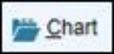 above calendar.

The patient workspace tab opens. Epic allows you to have up to 4 patient’s charts open at the same time. To close click the X
(do not do this now).

Verify you have the correct patient’s chart open by reviewing information in Storyboard.
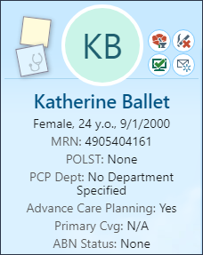

Storyboard

In a patient’s chart, Storyboard appears on the left side of the screen, and activity tabs appear along the top of the screen.

- Hover over any item in Storyboard to see more.
- Click information in Storyboard to jump to an activity to see more detail or take action.
- Click the back arrow to get back to where you were.
- Use the Chart Search to find the information you’re looking for. For example, enter urine micro to search the patient’s chart for prior labs results.

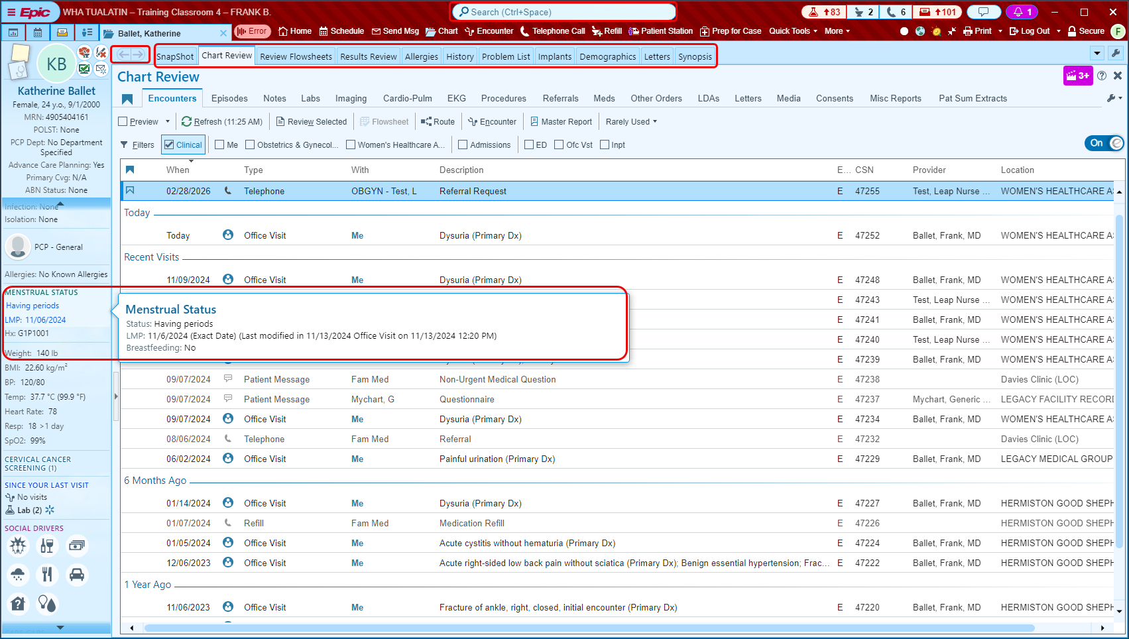

Storyboard present information in layers. The general rule is, more basic information is towards the top and more specialized information is towards the bottom.
You can glance at it for basic answers to your questions, hover to see more information and click to take action.
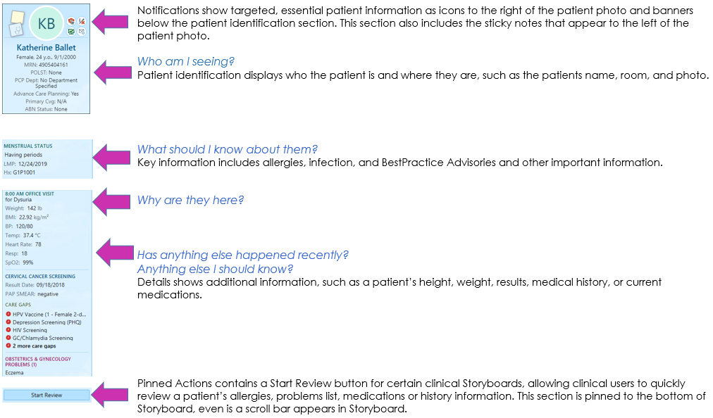

Create sticky notes 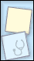 to leave reminders for yourself.
Suggestions are: hard to pronounce names, and/or big life events. Sticky notes appear in a floating window that you can minimize or close as needed.

Note: A sticky note is a piece of the chart that no one else will see, unless directed to give a copy of chart for legal or court purposes.

Let’s add a note that she will be going back to school to finish her Master’s in Teaching.
- Click the blue Sticky Note icon  to leave a note in the patient’s chart that you and other providers in your specialty can see.
- Click the yellow Sticky Note icon 
- Drag the window down to an open section of the workspace.
- Type in note about ‘Receiving masters in teaching’.
**Note: It’s recommended to add dates to comments in this box. This will help keep a good timeline of what is going on in the patient’s life and make building rapport easier.**
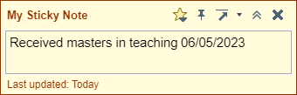
- Click the Chevrons to minimize, the X close the note entirely. Clicking the arrow moves the note to the upper right corner of the workspace or set a new home position. Clicking the Pin keeps the sticky note open in the patient’s chart. The Star has All Tools available such as spell check, SmartPhrases, SmartLists and more.
- Gray lines 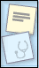 indicate there’s text in the sticky note. Hover to read the note, or click to edit it.

To open Chart Review, click on Chart Review in the list of activity tabs.

Chart Review activity tab: 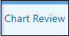

- Encounters tab: This section is where you can find all encounters, we have with the patient. This includes telephone, office visit, orders, patient emails.
- Locate the Last annual visit. (5 years ago, section)
  - Single click for Preview of report.
  - Double click to see the report in almost full screen.

There are Bookmarks and default filters that sort information by selecting or unchecking the checkbox.
- Episodes tab: Episodes are events to which services provided can be linked. Common uses for episodes are care management, worker’s comp, and, of course, pregnancies. Refer to the episode tab to see all services provided for a specific episode.
- Notes tab: Able to filter or view different note types separately, documentation from all encounters.
- Labs tab: All lab test orders and results from all encounters, procedure notes, op reports, etc.
- Imaging tab: All imaging orders and referrals (excludes external imaging orders
- Referrals tab: Where all referrals live, including external, internal, and referrals for external imaging (fax referral orders from here, but not imaging orders)
- Meds tab: Defaults to show patient’s Current Medications. Deselect to review all historical medications prescribed or documented in the chart.
  - Uncheck the Current Meds Only filter to see Historical Meds.
- Other Orders tab: Route external imaging orders from here after provider has co-signed them. Orders for Durable Medical Equipment (DME) reside in this tab as well.
- Letters tab: Epic generated letters printed or sent to patients are in this tab
- Media tab: All scanned documents and images uploaded into the patient’s chart. As documents get scanned, it is critical to add comments for searching capability.
- Consents tab: All documentation that has been electronically signed (i.e. consents)
- Misc. Reports: Allow you to review additional information:
  - Routing Hx,
  - My Chart Report (a report for all MyChart communications)

Now that I have shown you the long way to review a chart… Let me show you a more efficient way to do so.

Locate the Epic Search field on your Hyperspace bar.
- Type Dysuria.
- Review the previous documentation.
- Hover to discover information.
- Click the X  to close the workspace tab.

Exercise 2: Quick Visit Documentation

Scenario: Katherine is coming in today for painful urination and you see that the support staff have flagged you with a green dot, that their documentation is complete. Use some of the reporting tools, located below your schedule, to get up to speed with your patient.

- Click the Rooming Report on the bottom report pane.

Note the Reason for Visit or Chief Complaint, and Vitals that have been documented.
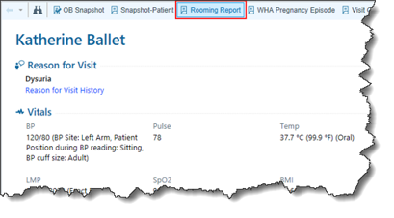
It is protocol for staff to run a UA test and pend a urine culture order, so you will check to see if that test has been ordered and resulted yet in the Visit Orders report.
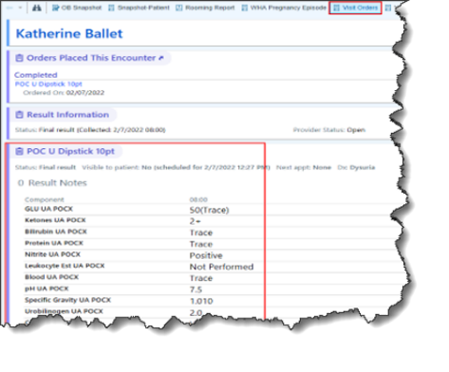
You are ahead by knowing this information before going into the exam room.

- Double click to open the patient’s visit encounter.
- Click on Start Review located at the bottom of the patient’s Storyboard (this is the first way of reviewing the patient’s information).
A Marked As Reviewed window opens.
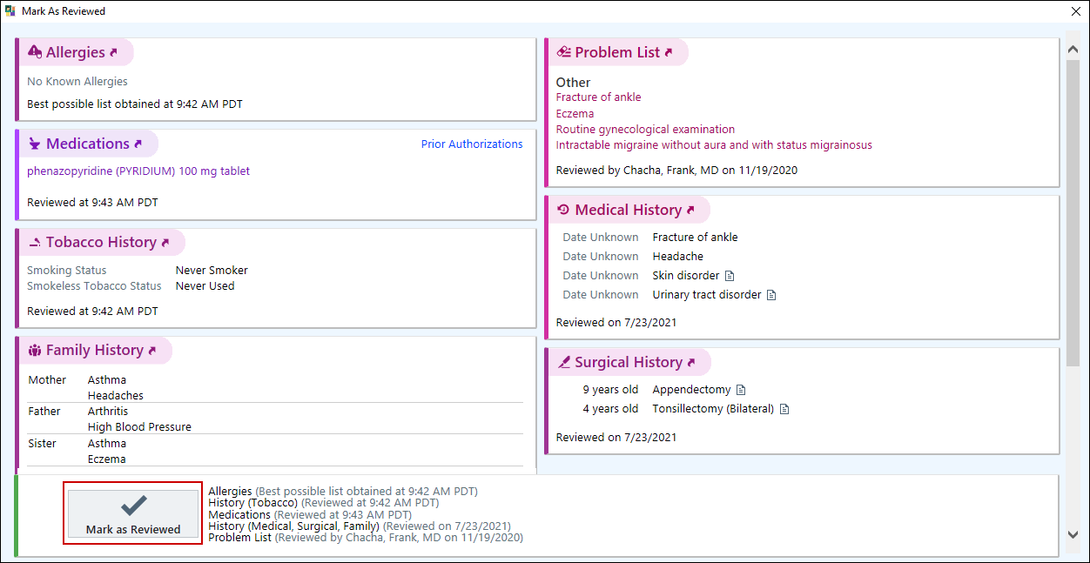
This allows you to quickly review a patient’s allergies, problem list, medications and history information before you go in the room.

- Click Mark as Reviewed.

The first time you log into EPIC, you will need to open the sidebar where your note activity is located by clicking on the blue arrow to the right of your screen.

Progress Note Activity: 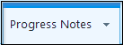
This activity is located in the top upper right of your Show Tasks side bar

- Click the dropdown arrow next to the Create Note button.
- From the menu of options, select WHA GYN VISIT.
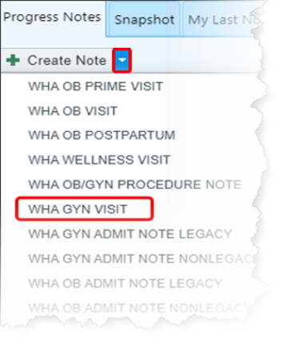
Complete Documentation.

- Click the HPI tab to access the documentation for this section in the NoteWriter activity.
- If the Dysuria form is not already present, type Dysuria in the Add an HPI search field.
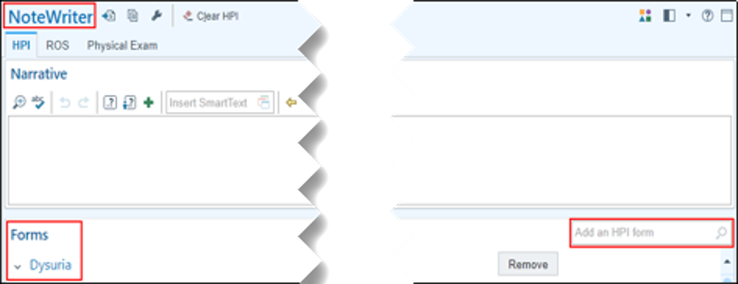
- Make some selection to the form such as Onset, Frequency, and Pain as well as any Associated symptoms.
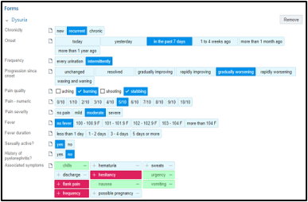
Notice how your note has begun to develop on the right of your screen in the Progress Notes section.
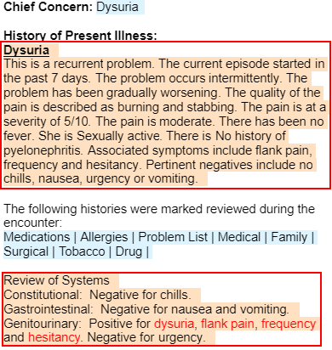
Now quickly pull in information from other places in the chart using smartphrase.

- Type .THISVISIT pulls in the UA result of today’s test in the HPI section of the Note.
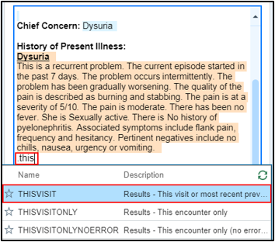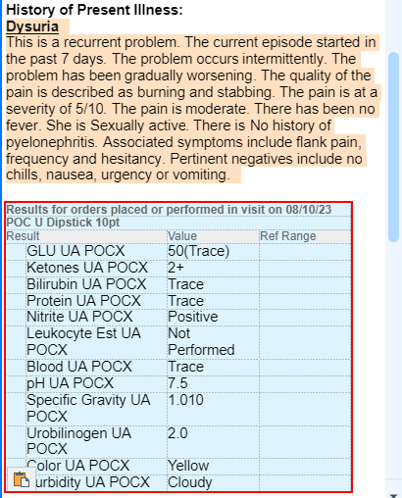
Now, document the Review of Systems.

- Click the ROS tab to quickly access the documentation for this section and complete your assessment.
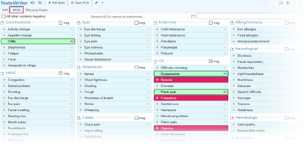
Let’s go into the Physical Exam documentation.

- Click the Physical Exam tab.
- Make selections of your findings with the patient.
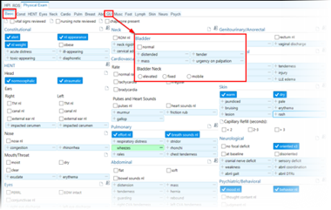
You will complete the variables for Chaperone and Coding Attestations later in this exercise.

This Visit Activity: 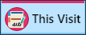

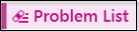

You have reviewed the results of the UA test and noted that Katherine has a positive 10 dip, indicating a potential urinary tract infection.

Let’s review her problems list and document your assessment and plan.

- Click Urinary tract disorder name to get more information on this patient’s problem.
- Click the icon next to Urinary Tract Disorder to change the diagnosis and preserve the historical record of the problem as it evolves.
- Type: acu cys.
- Select Acute cystitis from the list
- Select with hematuria for a more specific diagnosis.
- Click Accept, then Accept again.
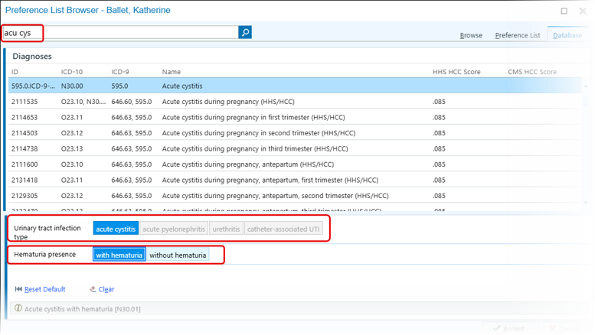
Add to Overview section. Reminder, this section is meant for historical information for quick reference, such as “frequent UTI’s”.

- Clickthen add a note about frequent UTIs over the last two years.
- Click Accept.
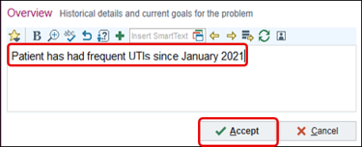
- Click Current Assessment & Plan Note
Document your plan for the patient.
- Continue to document that culture was sent and medication prescribed.
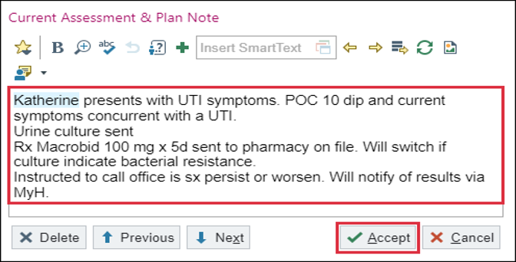
- Click Accept.
- Scroll to Relevant Medications and review medications related to the problem or add a new medication right from here. You will do this in a later exercise.
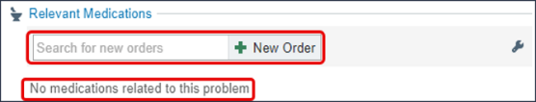
- You can click Associate Signed Orders before leaving the Problem List section to avoid having to complete this task later. We will explore this in a later exercise.
- Click Mark as Reviewed if you did not complete this task at the beginning of the visit.
This will automatically include Acute Cystitis in the Visit Diagnosis section.

You’ve seen the result of the UA Test and know that Katherine is positive for Leukocytes and has another UTI. Dysuria is listed, because it was associated with the UA dipstick that was completed by Support Staff so it cannot be deleted.

Make sure Acute Cystitis is set as primary diagnosis.
- Place your courser in the white space next to Acute Cystitis.
- Single click on the diamond.
- Use the hand to move diagnoses up and down in the list.
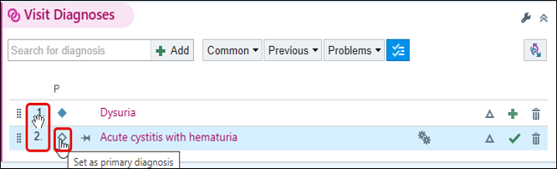

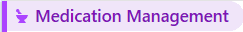

Notice that the patient has Pyridium on her list, but is no longer taking, due to the therapy being completed. First, discontinue the Pyridium from the patient’s medication list.

- Click the X next to the Pyridium medication.
- From the Discontinue Prescription window, update the Discontinue Reason.
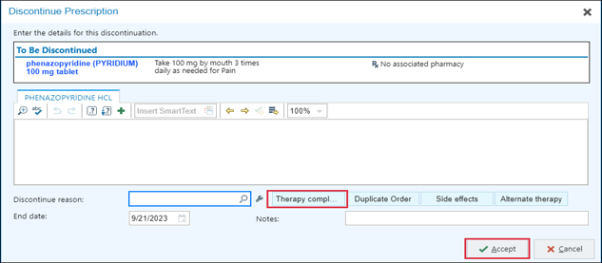
- Click the Therapy completed button.
- Click Accept.

You would like to remove Dysuria from the Visit diagnosis activity to clean up the Note and prevent Note Bloat.

First, you will need to change the diagnosis code on the signed POC 10 dip order.

- Click Associate Signed Orders button at the bottom of the activity or click on the clipboard icon located on the bottom right corner of the visit task bar.
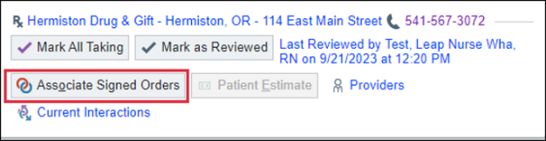
- Use the check boxes to associate the correct diagnosis code.
- Click Accept.

A Dx Association box opens.
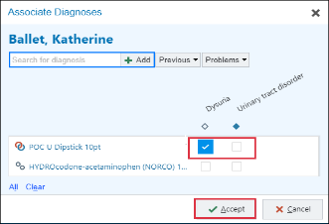
Once you click Yes, you’ll be able to remove Dysuria from the Visit Diagnosis activity.

- Click Yes.
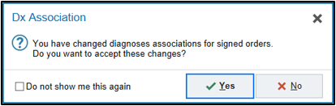
Now let’s place an order for a new prescription. You have decided to prescribe Macrobid.

- Click 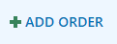 in the visit taskbar at the bottom left of the workspace.
- In the Search for new order 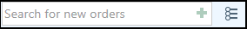 field, type Macrobid.
- Press Enter.

You want to order a prescription for the patient to pick up at a pharmacy.

- Click the Facility List tab (top right) - has a few selections for you.
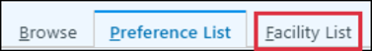
  - If that is still not what you are looking for, click the Database tab.
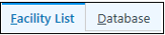
The house icon means this is a prescription to have the patient go pick up, vs the syringe is for clinically administered medications/injections.
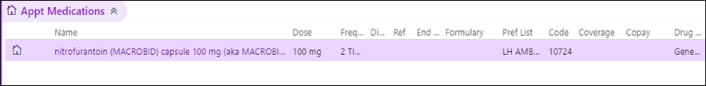
- Double click the Macrobid prescription or click Accept.
- Your queued-up orders can be seen in the visit taskbar.
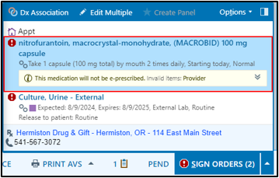
- Complete Duration: 5 Days.
- End date automatically updates, adding the Dispense and Refills.
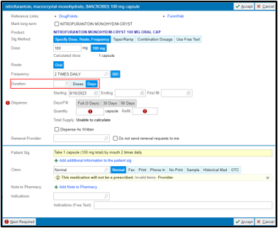
- Verify the Patient’s Pharmacy is correct: Hermiston Drug & Gift in Hermiston, OR.
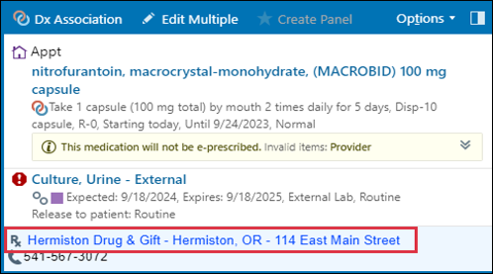
- Dx Assoc: 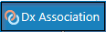 Associate with the Visit Diagnosis.
- Click Accept.
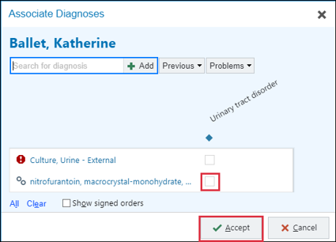
- Click Sign Orders (2)

It’s time for me to Wrap Up this visit.

Today Katherine and I discussed reasons she may be having frequent UTI’s. I want to send her home with some information.

This information will be added to the after-visit summary that is printed for the patient at the end of each visit AND is also visible in MyHealth.

You can use the system to search for visit related materials that are available in EPIC. Let’s explore what education is available.

- Click the Clinical References hyperlink or use References icon above the Patient Instructions box.
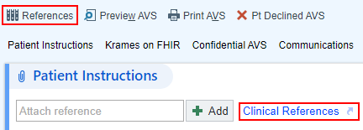
Clinical References pulls suggestions from the Diagnosis and Problems listed for the patient.
- Select URINARY TRACT, FEMAL ANATOMY (ENGLISH).
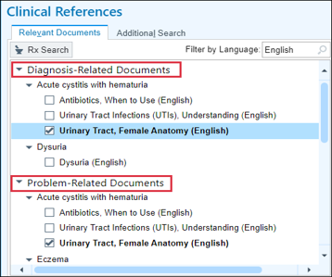
Review the information in the Document Preview.

- Check a box next to the appropriate document to review or add it to the Patient Instructions (PI).
- Click the X top right of this workspace. The document will show as an attached document.
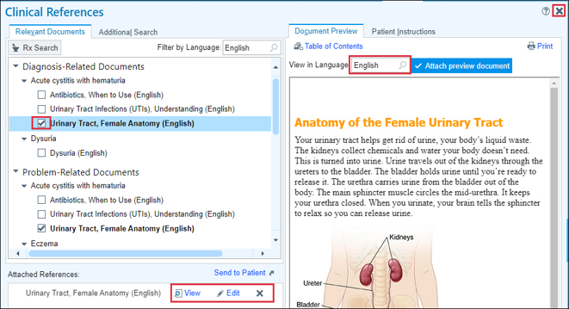
Notice the attached education is seen in Patient Instructions.

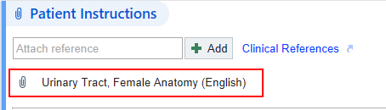

I would like Katherine to come back if her symptoms do not improve in a week.

- Return in: PRN. Click the white box to add pre-selected return recommendations.
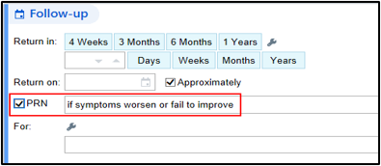

Katherine says that she missed work yesterday and today due to this issue and would like a letter from you excusing her.

- Select the patient as the Recipient.
- Click the box next to Route draft to staff.
- Routing Recipients: P WHA POD TN.
- Choose Routing Instructions if applicable.
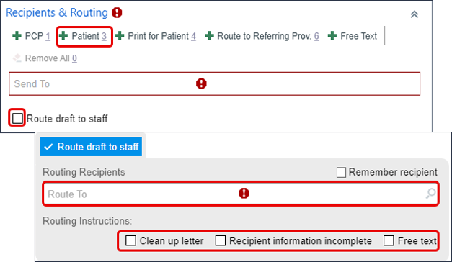
- Click the Work/School Excuse button to open letter with the WHA logo.
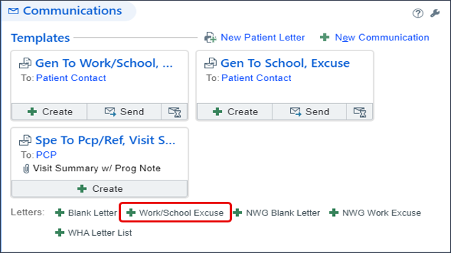
- Click the magnifying glass in the letter or use F3 to zoom if needed – to review and/or make any changes.
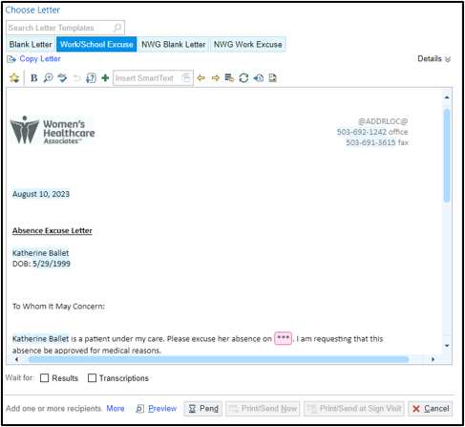
- Press F2 or click the variable to access the first variable that needs to be answered.
- Click Replace Template then the magnifying glass to see all letter templates if you decide on a different letter.

This will delete the current letter if you decide to change the template.

- In Recipient & Routing, click Patient.
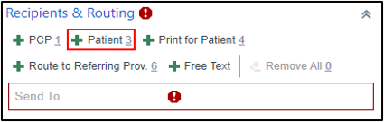

If patient decides she would like it sent to her employer.

- Click Free Text to open the Edit Recipient window and fill in employer Name and Fax number.
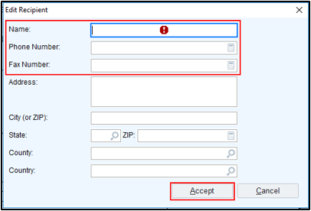
- Click Accept.
- Click Send Now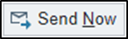.

Confirmation that the message was sent shows in the bottom right corner.

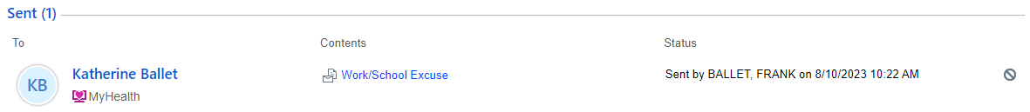

You are mostly done. There are a few things you need to finish up before signing the visit.
Now preview the AVS.
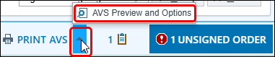
- Click AVS Preview and Options to make changes to the Font Size or language as needed.

You are mostly done. There are a few things you need to finish up before signing the visit.

Progress Note Activity:

F2 or Scroll to the bottom of your Note and click the WHA CODING ATTESTATION and choose either TIME or Medical Decision Making (MDM) criteria.

- Single click MDM.

Each patient will be offered a chaperone for their visit. Katherine has requested a chaperone be utilized for any sensitive exam performed, however she does not require a sensitive exam.

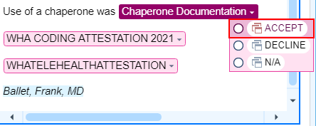
- Satisfy the chaperone variable; select Declined.
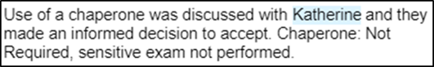

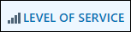

Next, I need to document the Level of Service for today’s visit.
- Click the Level of Service 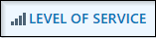 from the visit task bar.
- Choose the appropriate LOS code button using your Coding E&M Sheet.
- Click EstLev4 for a 99214 code.
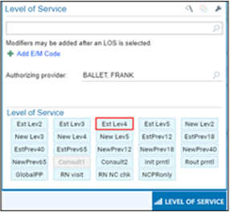
- Click the Sign Visit activity

The system recognizes there are areas that have not been completed for this patient. Since you have already reviewed the POC urine dip, you can check these off. Do not check off the urine culture.

In Results to be Reviewed, check the box next to POC U Dipstick 10pt.
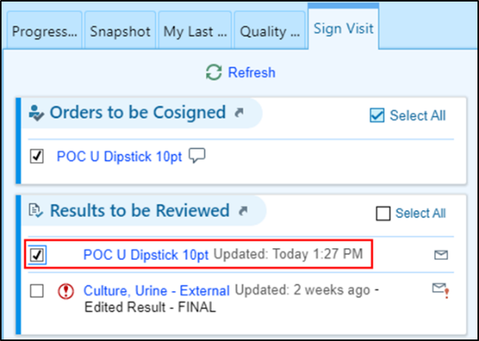
You can complete these now, then click the Sign Visit button. Epic will close the encounter and the status on the schedule will change to “Signed”
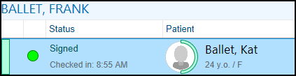

Exercise 3: Pre-Charting – EST WELLNESS VISIT – ANNUAL

Scenario: Maria has an apt today for a Wellness visit. The patient is not here in clinic yet, but we can take the time to “Get up to speed” with what has been going on with her recently.

- Single click on Maria’s “Scheduled” appointment time.
- Review the Snapshot report.
- Now, double click to open patient’s chart

Because this visit was still at a Scheduled Status, and the patient is not in clinic yet…. This will open the Pre-Charting activity
There are advantages of pre-charting
(DO NOT CLICK START VISIT) 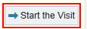

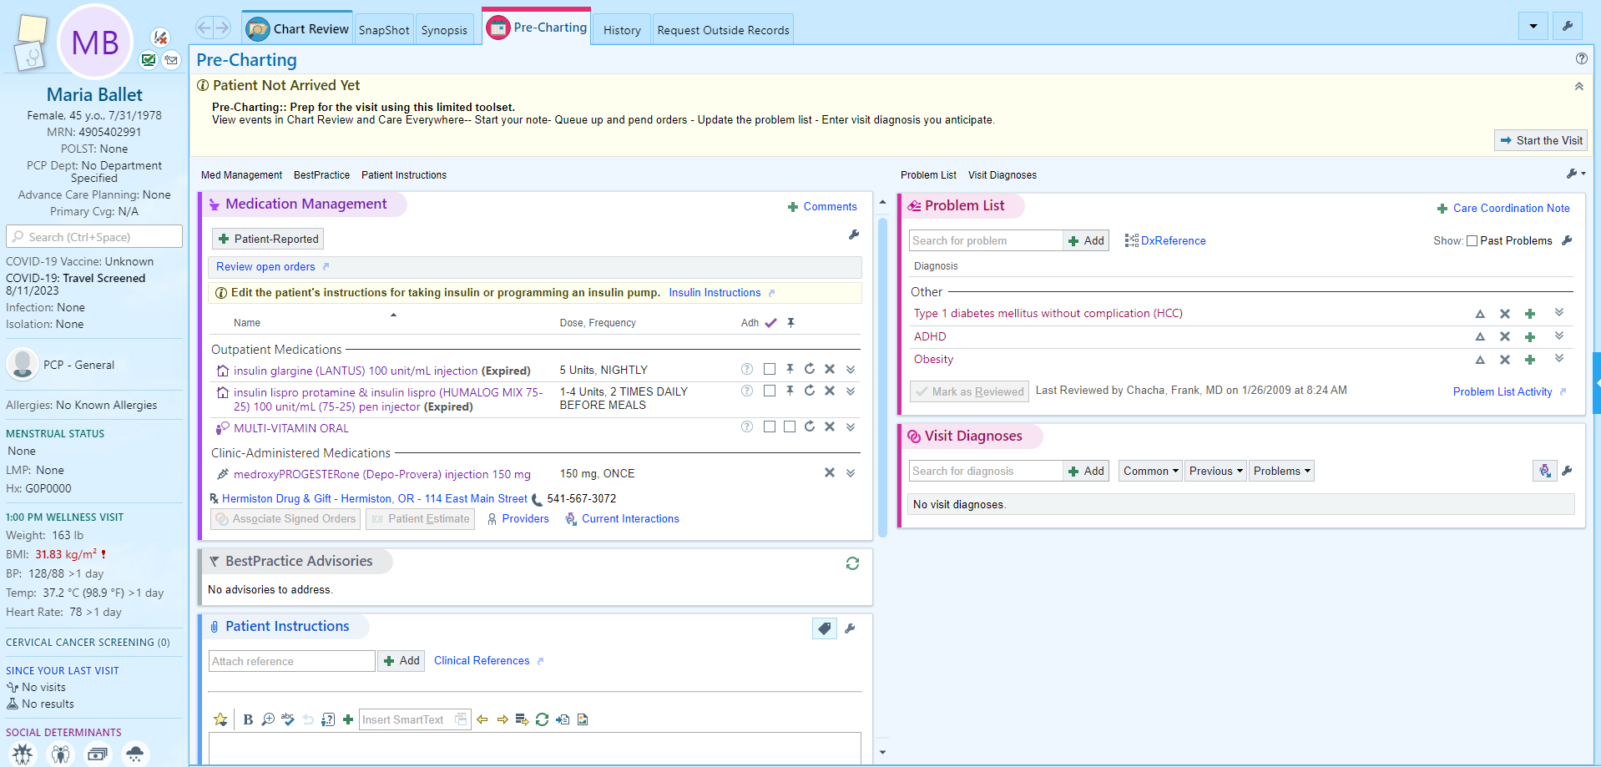
Pre-charting: You can prepare for the visit using these limited toolsets.

- View events in Storyboard, Chart Review and Care Everywhere
- Start your note and insert templates
- Queue up and pend orders
- Update the problem list
- Enter visit diagnosis you anticipate
- Add patient instructions/education

Do some of your Problem Oriented Charting for Well Woman visit, Obesity.
Move Problem List – Obesity to Visit Diagnosis if applicable.

The work that you do in pre-charting will save for 30 days should your patient reschedule her appt. This information can also be utilized by others if the patient reschedules with another provider in WHA.

Module 4: Use the Card Viewer

Exercise 1: Respond to Patient Call

Scenario: As we walk past our MA’s desk, she tells us that an advice nurse sent us a message regarding our Odette patient.

Sidebar – Card Viewer (Results, Rx Refills, and Patient Calls/ Communications)
- Click the Patient Communications Icon
- Locate your Odette patient and single-click on the message.
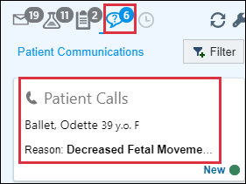
Your Advice RN team has created a Telephone Encounter for your Odette patient. You will review the message from the support team and make any necessary clinical decisions for patient care.

You want to see when Odette’s next appointment is scheduled.

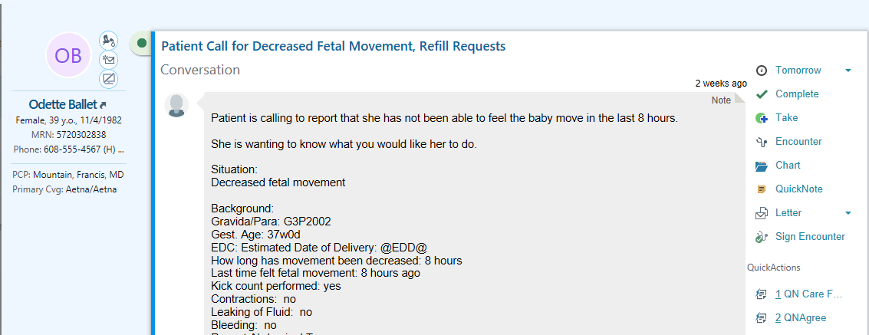

- Click the Patient Visits/Info report at the bottom left of the message.
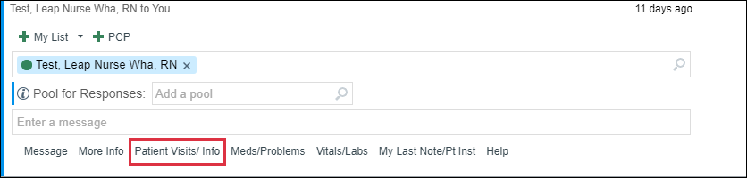
You see that she has an appointment later today.
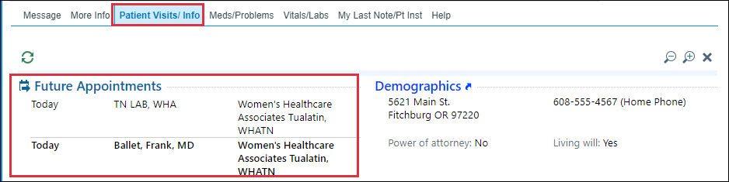
First scroll back up to the top of the message and use the actions to send a respond to your support team.

Document your recommendations, to have advice call to confirm her appointment today and inform her that she will need to arrive at the clinic 30 minutes prior to her appointment today for a non-stress test.

- Select Reply under Other Actions.
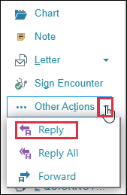
- In the To field, notice that Test, Leap Nurse Wha, RN is listed.
- Subject: NST needed.
- Type in your note.
- Click Send button.
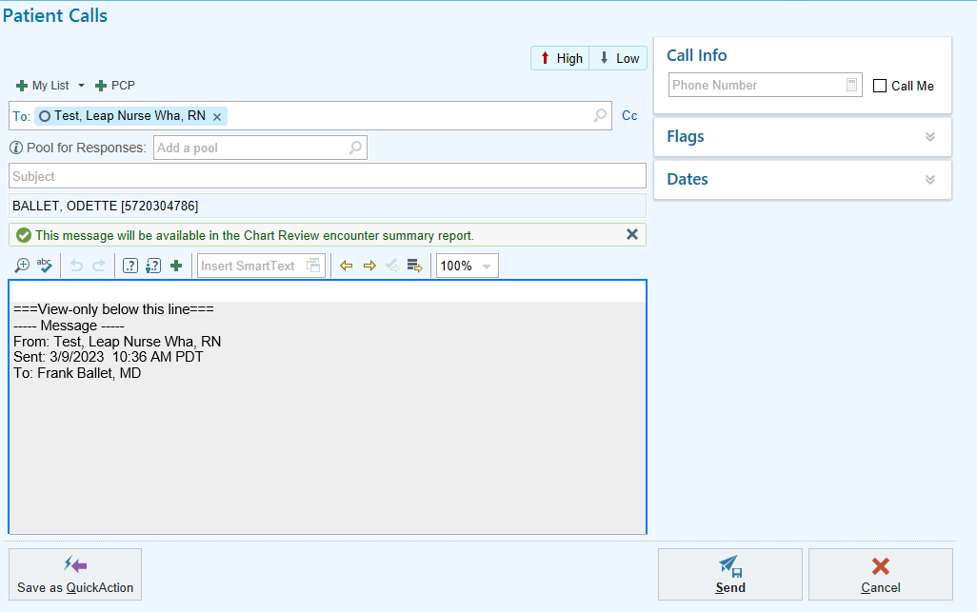
- Click Done 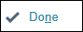

Epic will remove completed work so only active tasks are shown.
How do we get back to the multi-provider schedule?

Review your work in Chart Review under the Notes activity(Telephone Encounter)!

Module 5: Clinic Visits/Procedure Workflows

Exercise 1: EST WELLNESS VISIT – ANNUAL
Scenario: Gretchen has arrived for her wellness appointment, and the notes show that her last Pap test was performed in 2016. Take a moment to review the relevant reporting tools to get up to speed on your patient.

- Click the Rooming Report on the bottom report pane to review information already entered by support staff.

Now let’s look at what orders may have been placed for our patient.

- Click the Visit Orders report on the bottom report pane.
- Notice a PAP Smear order is Pending.
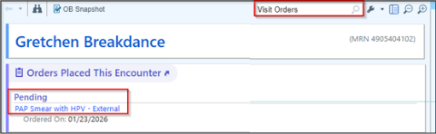
You are ahead by knowing this information before going into the exam room.
Double click to open the patient’s visit encounter.

- Click on Start Review located at the bottom of the patient’s Storyboard.
- Click Mark as Reviewed.

Progress Note Activity:

You should have reviewed the Note and what was documented by your support staff in the Rooming Report on the preview pane to save time.

- Click Edit to document in the existing Progress Note.
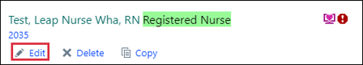
All patients complete a Well Being Assessment (WBA) prior to their Well Woman Exam. Once you have the WBA, you can use it to assist in completing the variables related to Depression, CAGE, and SUD screenings in the Note.

- Review the Depression Screening information in the Note.

Gretchen’s score indicates no increased risk depression according to the table, based on her score of 0 in the PHQ9. Her Suicide Ideation is Negative.
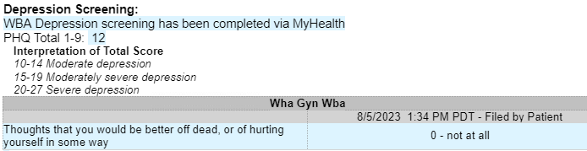
- Single click the box next to Medical therapy discussed and/or offered today, then right click to save the selection.

Review the patient’s SUD Screening. She does not screen positive. Utilize the WHA SUD Interventions SmartList to document.

- Press F2 or click to access the SUD Interventions SmartList.
- Single click to check the box next to N/A, patient did not score positive for substance use screen, then right click to save selection.
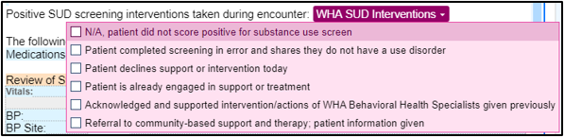
Document the Review of Systems.
- Click the ROS 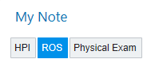 button to quickly access the documentation for this section.

There are templates that you can create and save with your pre-configured exam preferences that we will explore further later in your training.
Let’s document the Physical Exam.
- Click the Physical Exam SmartBlock.

Make selections of your findings with the patient under Basic. Paula reported breast tenderness on her left side. Quickly document this with a few clicks.

- Click the Breast tab.
- Begin making selections.
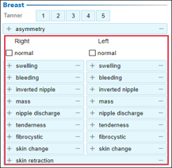
- Click the plus sign for tenderness of left breast.
- Hover over and start typing to add a findings comment.

Now let’s complete your documentation of her physical exam using other pertinent exam tabs.
- Abd
- GU – External, Internal, Pelvis Floor, Anus/Perianal if applicable.

Before moving on, complete the remaining variables in your note template.

Review the patient’s request for a chaperone. Gretchen has requested to have a chaperone present as seen in her Storyboard. This needs to be documented in the Note.


- Press F2 or click the Chaperone Documentation SmartList.
- Double click Accept.
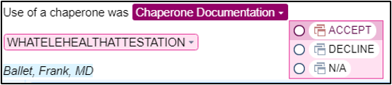
- Document the name of the chaperone in the wildcard that has pulled into the note.

This Visit Activity:

In the This Visit activity, you have the capability to complete most of your documentation from a centralized location.

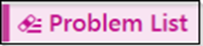
Gretchen is here for her wellness, pap, and to discuss menopausal symptoms.
- Type well woman and press Enter
- Select Well woman exam (1st on the list)
- Click Continue to A & P and document your plan for the patient.

You can choose to document the discussion about hormones under Well Women Exam if it’s an uncomplicated concern or you can add to the patient’s problem of Menopausal symptoms to document a more complicated problem.

- When finished, click Accept.
- This will automatically add to Visit Diagnosis section.
- Click the Mark as Reviewed button if you did not complete this task at the beginning of the visit.

This would be a good time to resolve any problems on Gretchen’s Problem List that are now resolved.
- Hover over the X next to the problem you wish to resolve to view the list of choices.
- If there is a problem that you would like to add to Gretchen’s History, select Resolve & Add to Hx or Resolve.

What was the purpose of the visit today?

- Change the Primary diagnosis to Well woman exam.
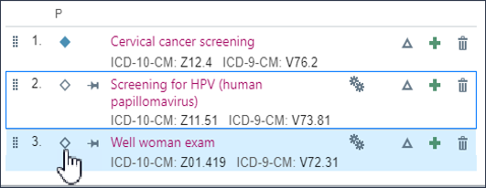

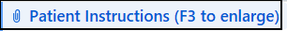

Support staff has already pre-loaded education about staying healthy.

Discuss with patient that you would like her to come back in 1year for Well women’s exam unless her pap results come back abnormal. You may also want to have your patient return in 3 months for a follow-up on hormones. Add the appropriate follow-up for this patient.
- Click the wrench 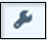 to add speed buttons for other return visit types.
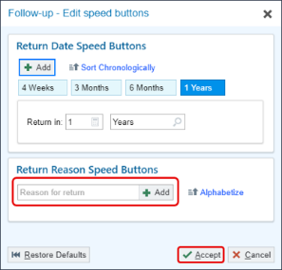
- Click Accept when done.

Another part of Meaningful Use measures is to give the patient a copy of today’s visit.

Now preview the AVS.
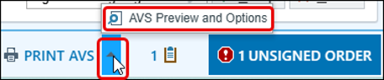
- Click AVS Preview.

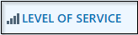

Level of Service for this visit will be a Wellness visit.
Let’s document the level of service now.

- Select the appropriate level of service.
  - In this scenario you will choose ESTPREV40 for the LOS.
  - If needed, add any additional EM codes.

You have completed your note and documentation for this visit. Now it is time to sign the visit. Make sure you go back and click the refresh button in your ‘Progress Note’ one last time.

- Click the Sign Visit 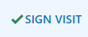.

Exercise 2: Procedure Visit – Colposcopy

Scenario: Greta is scheduled for a clinic visit today to undergo a colposcopy.
Use some of the reporting tools to get up to speed with your patient.

- Double click to open the patient’s visit encounter.
- Click on Start Review located at the bottom of the patient’s Storyboard.
- Click Mark as Reviewed.

Progress Note Activity:

There is a new feature for procedure documentation. For this exercise, your support team has started the note using a procedure template.

- Click Edit .
- lick on the Procedures button.
- Notice your MA added the procedure, documented the Consent pieces she reviewed with the patient and added Procedure location.
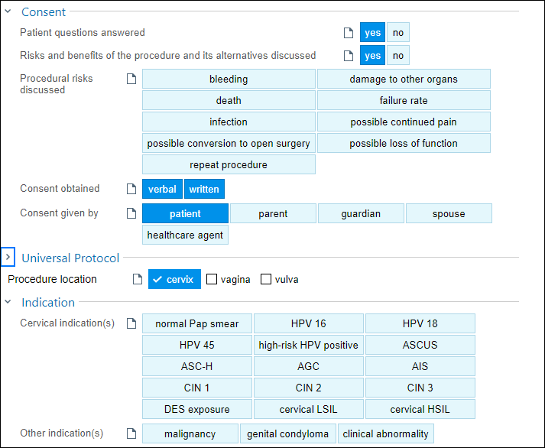
Complete the documentation.

- Consent section: click the heading to open the section if not already open. Document the information in Procedural risk discussed with patient.
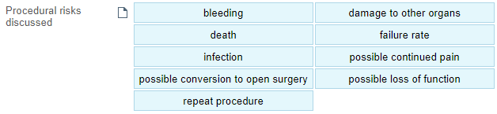
- Universal protocol for specific documentation. Used only for IOS cases. Click the heading to minimize the section if it’s open.
- The Procedure Location in this section is a hard stop.
  - Click the check box next to cervix if your MA has not already clicked it.
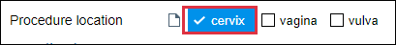
- Indication: ASCUS, high-risk HPV positive.
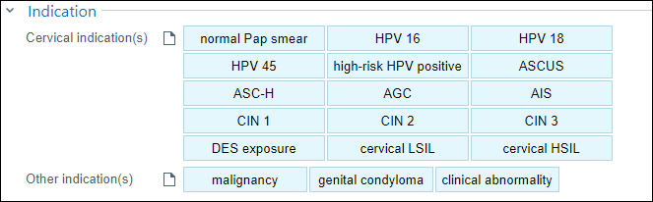
- Pre-Procedure documentation
  - Premeds: Ibuprofen In the comment box, add the dosing
  - Prep Solution: acetic acid
  - Local Anesthetic: if applicable
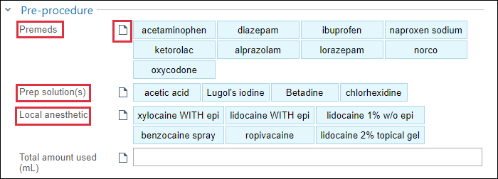
- Procedure documentation:
  - Click Colpo of cervix w/ biopsy and ECC
  - Add documentation of patient placement, instruments, blocks as well as other details of the procedure.
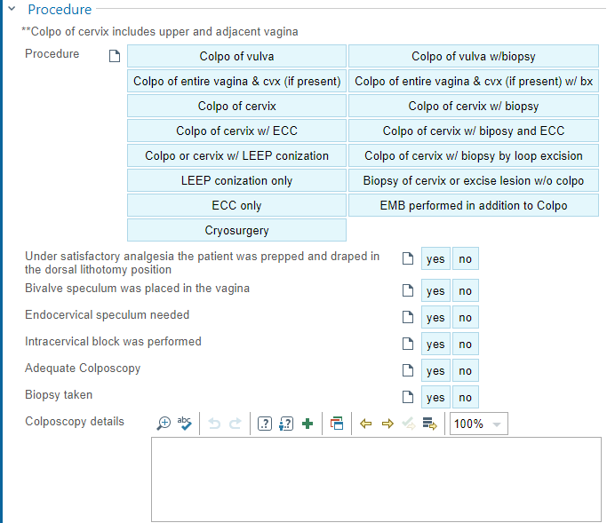
- Findings: Click on all that apply.
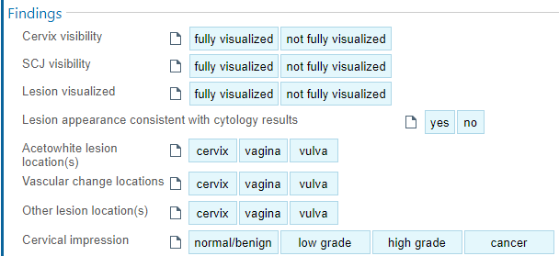
- Post-procedure documentation: Select options that apply using your clinical judgement.
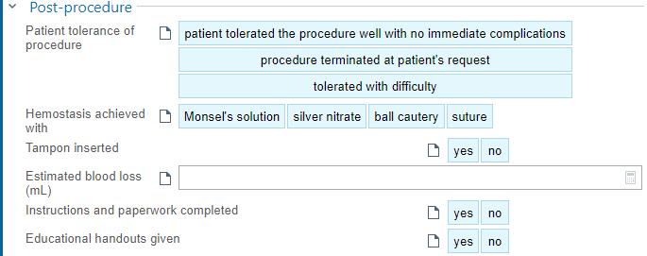
Let’s go into the Physical Exam documentation.

- In the Progress Note click the Physical Exam tab.

Using your clinical judgement, make some selections for your findings with the patient under the GU activity tab.
- Click the GU from you top activities tabs.
- Select the Internal navigator.
- Begin making selections.
- To add a comment to lesion, hover over the specific item and begin typing.
- Click the green check when done.
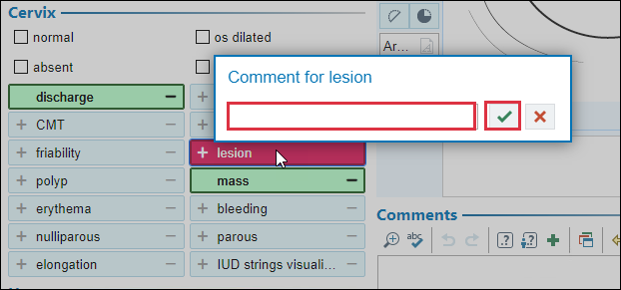
- Use the cervical image to document biopsy sites for future reference.
- Use the tools to the left and top of the image to write/draw on the diagram.
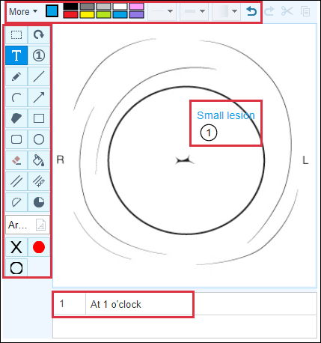
- When complete, the image will appear in the body of your note.
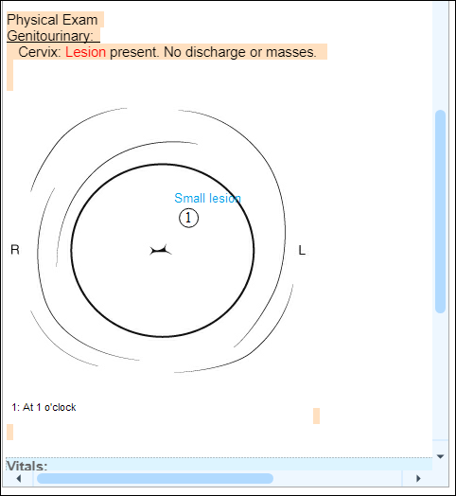

This Visit Activity:

Document your assessment and plan on the Problem List.

- Locate the ASCUS with positive high-risk HPV cervical on the Problem List; click the name to open
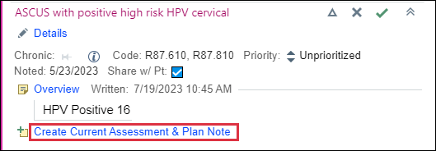
The Current Assessment & Plan section is a place to document your assessment and plan for this problem.

- Click Current Assessment and Plan to document your plan for the patient.
- Type note: Recent pap: ASCUS, HPV+16, (18/45. neg) Colposcopy preformed with Biopsies at 2:00. 8:00, and ECC10 o’clock and ECC. Low grade in appearance.
- Click Accept.
- Click the Mark as Reviewed button.
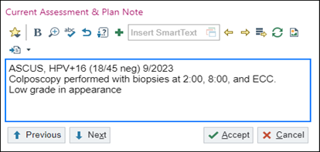
Now it is time to discuss the HPV immunization Health Maintenance Advisories with the patient.

She is here for a Colposcopy procedure due to Abnormal pap finding. You recommend getting the HPV vaccine after her procedure.

Now you can place an order for any lab or vaccine that is needed after the procedure. In this situation, your support team has added the tissue specimen order.

Let’s look at what clinical information still needs to be added.

- Click 2 UNSIGNED ORDERS located in the visit task bar.
- The Tissue Pathology order window opens the details.
- Update the Clinical Information:
- Add additional Clinical information; Type: ASCUS HPV 16 Positive.
- Update the Specimen source 1: type cervical biopsy at 2 o’clock.

Subsequent biopsies are recorded on individual specimen source lines.

- Add Specimen source 2: type cervical biopsy at 8 o’clock
- Add Specimen source 3: type ECC.
- Click Accept.
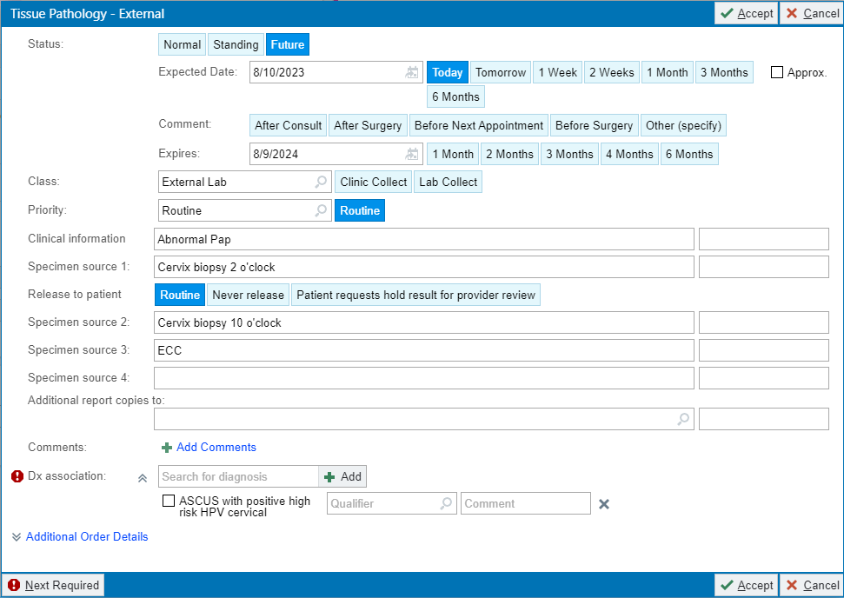
- Click Dx Association
- Check the box to associate the orders to the appropriate diagnosis.
- Click Accept.
- Click Sign Orders.

It is time for me to wrap up this visit. Today Greta and I discussed her Colposcopy procedure.

The Post-Biopsy/Colposcopy instructions have already been added to the Patient Instructions box by your support staff.

Next, I need to document the Level of Service for today’s visit. This activity can be found at the bottom of your screen in the visit task bar.

- Click LEVEL OF SERVICE from the task bar.
- Select the NCPRONLY button to document, PR PROCEDURE ONLY NO CHARGE.

Discuss with patient when you would like for her to come back. You may choose in 1 year for her Well Women’s Exam unless her results come back abnormal.

- Go to the Follow-up activity.
- Return in: Click 1 Year.
- For: well woman exam

Preview the patients AVS

- Click AVS Preview and Options to make changes if needed.

Review documentation and refresh your note prior to signing your visit.

- Click the Sign Visit.

Exercise 3: GYN Telehealth Visit

Scenario: You see that Grace is scheduled for a telehealth visit due to vaginal discharge.
Use some of the reporting tools, located below your schedule, to get up to speed with your patient.

- Double click to open the patient’s visit encounter.

When you open the encounter, you will be in Pre-Charting. You may select your preferred note template and use whatever is appropriate for the visit type. Obviously, the fields for vitals will be empty.

Progress Note Activity:

For this telehealth visit, start the note template you know you want to use.

- From the menu of options, select WHA GYN VISIT

You will complete your progress note, ROS and Physical Exam later in this exercise.
When you have the patient on the video call, it is important that you confirm State patient is in (Oregon or Washington) as well as Place: Home/Residence or Outside of Home/Residence.
Once you have that, click Start the Visit. Do not click it beforehand, in case the patient does not answer or is outside Oregon or Washington.
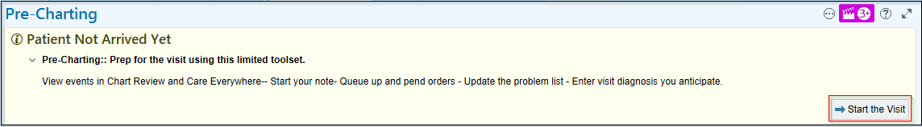
Clicking Start the Visit will make the encounter active and give you all of the functions you are used to having in a live encounter, including the Level of Service (LOS) and require you to sign the encounter when you have completed your documentation.
The Chief Complaint will need to be entered (either by you or your MA as part of your usual “Rooming/Intake” activities). In some cases, your MA may not be able to enter the Chief Complaint because they’re not speaking to the patient.
Go to the Rooming activity located in the top activity tabs of your workspace.

Rooming Activity: 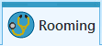

Go to Chief Complaint.

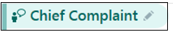

- Click on the section header
- Type: Vaginal discharge in the white search box or you can use a preset speed button.
- Click Close.
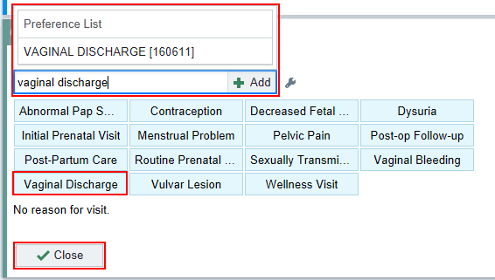

Now go back and update your note.

- Click the Refresh button.
- Chief Complaint is seen.
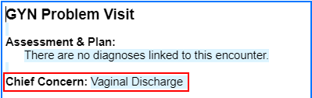
- HPI: History if present illness, including ROS and history if applicable.
  - If you use a Smartphrase, Press F2 – accesses first SmartList that needs to be answered otherwise, document using your clinical judgment.
    - Example documentation:
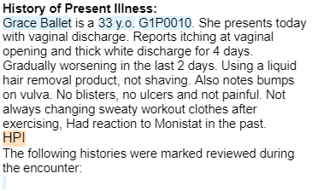

Document the Review of Systems.

- Click the ROS button
- Add to the fields if appropriate.

Document the Physical Exam if applicable to the visit.

- Complete your documentation of findings on any clinically relevant tabs.
  - GEN: Nothing Abnormal Detected (NAD)
  - RESP: normal work of breathing OR cough/sneeze
  - PSYCH: affect normal
  - ABD: flat
  - EXT: ambulating (if you see them walking)
  - Add any pertinent findings that you VISUALIZE.

This Visit Activity:

Add a problem to the patient’s Problem List.

- Go to the Problem List activity.
- In the Search for new problem search box; type vaginitis.
- Press Enter on your keyboard.

The Database Search window opens.
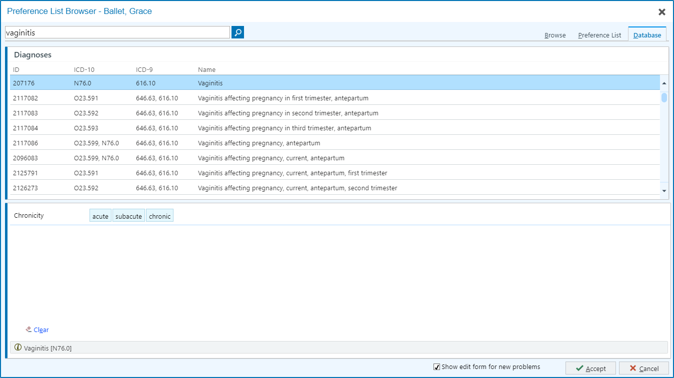
- Vaginitis (1st on the list) is already highlighted.

Select additional details to satisfy ICD 10 requirements.

- Click acute.
- Click Accept

The Overview section is meant for historical information, for quick reference, such as frequent UTI’s over the last 2 years. No need to document anything here for this exercise.

- Click Continue to A & P.
- Document your assessment and plan for the patient.
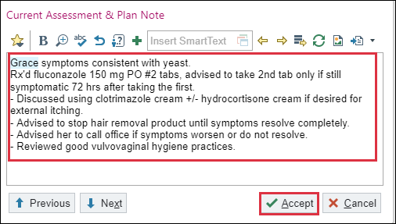
- Click Accept.

This will automatically add it to Visit Diagnosis section.

- Click the Mark as Reviewed button.

Now let’s place an order for a new prescription. You have decided to prescribe Diflucan.

- Click ADD ORDER in the visit taskbar at the bottom left of the workspace.
- In the Search for new order field, type Diflucan and press Enter.
- Select the Diflucan you wish to prescribe.
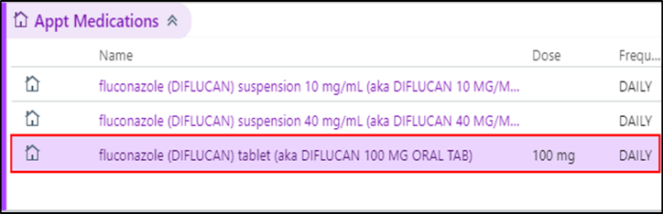
- Click Accept
- Your queued up orders are seen in the visit taskbar.
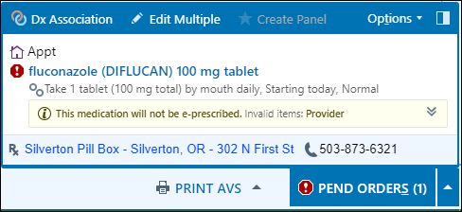
- Click fluconazole (DIFLUCAN)100 mg tablet.
- Frequency: EVERY 72 HOURS
- Duration: 2 Doses
- Refill: 0
- Class section: Normal – Will be e-prescribed/ sent electronically.
- Click Accept button.
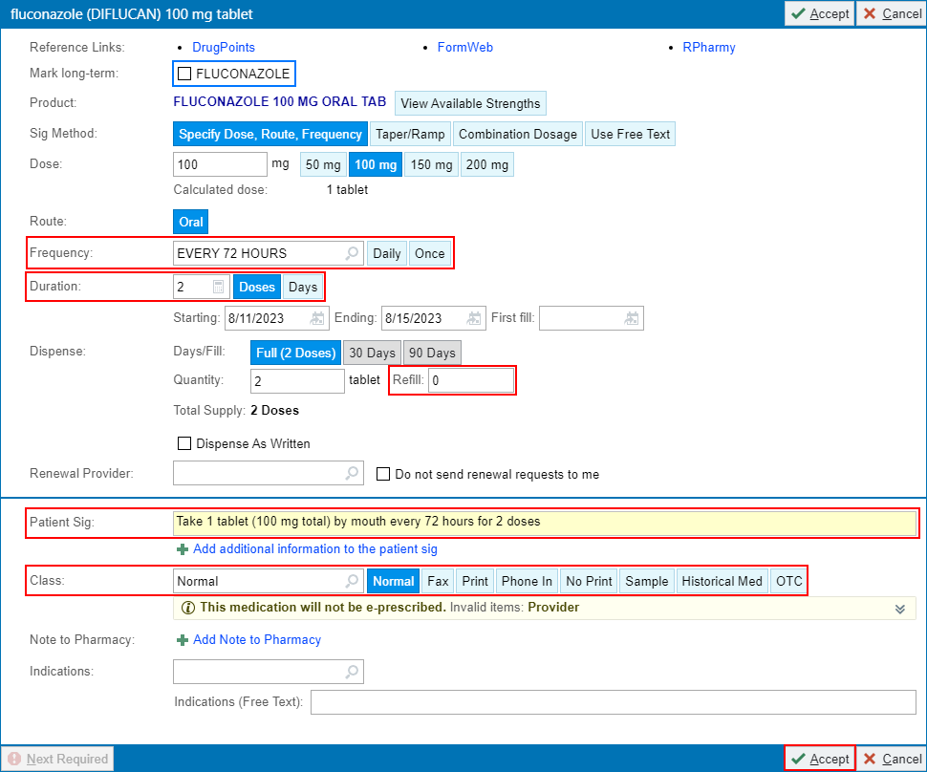
- Verify the Patient’s Pharmacy is correct: Silverton Pill Box – Silverton, OR – 302 N First St
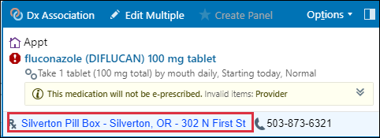
- Dx Assoc: associate with Acute Vaginitis.
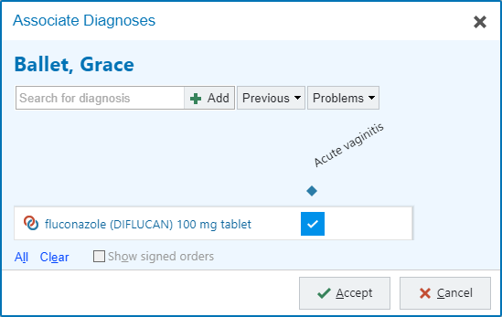
- Click Accept.
- Click Sign Orders.

It is time for me to “Wrap Up” this visit. Today Grace and I discussed reasons she may be having vaginal discharge.

You can use the system to search for visit related materials that are available. Search for the template for Vaginal Discharge.

- Go to the Patient Instructions activity.
- Click Clinical References hyperlink
- Select Vaginitis, Preventing (ENGLISH)

Review the information in the Document Preview prior to attaching it to patient instructions.
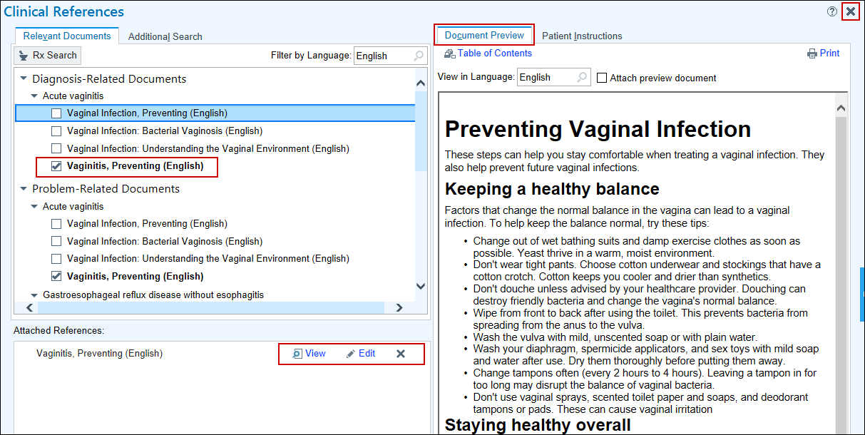
- Attached References: you can View, Edit or X the document using this section.
- Click the X top right of this workspace.

Notice the attachment in the patient instructions section.
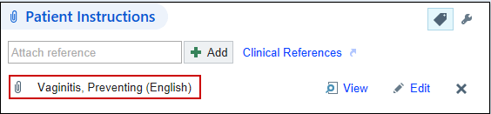

I would like Grace to call back if her symptoms do not improve.

- Go to the Follow-up activity.
- Return in: PRN. Click the white box to add pre-selected return recommendations.

I will now preview the AVS.

Progress Note:

A standard WHA Coding Attestation Smartphrase must be included at the bottom of all outpatient E/M visits.

- Refresh the Note.
- F2 or Scroll to the bottom of your Progress Note.
- Choose either MDM or TIME for the Coding Attestation.
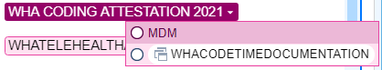
Each Telehealth appointment needs an additional attestation added to your documentation.
- Press F2 to access the SmartList for the telehealth attestation.
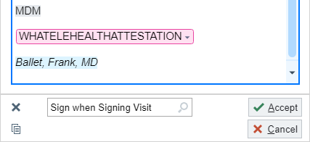
- Select the appropriate selection to invoke the attestation.
  - For this appointment, because we were able to connect via video, double-click to select Video visit.
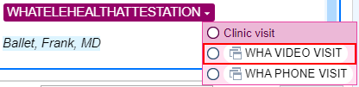
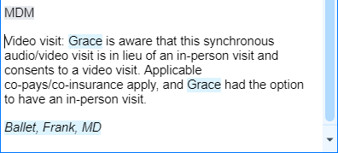
- Document patient’s location at the time of the visit. Remember: you should have verified this with the patient before starting the visit.
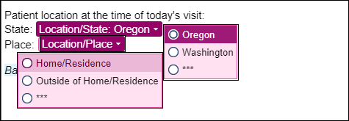

Next, I need to document the Level of Service for today’s visit.

- Click the Level of Service from the visit task bar.
- Choose the appropriate LOS code button; click Est Lev3 to document PR OFFICE/OUTPATIENT ESTABLISHED LOW MDM 20.
If necessary, you can use the Coding Wizard to help you select the correct LOS for this problem visit.

- Click on the Level of Service activity from the bottom task bar.
- Open the calculator by clicking the wand if needed.

You completed your note and now it is time to sign the visit once more. Make sure you go back and click the refresh button in your ‘Progress Note’ one last time.

- Click the Sign Encounter activity

Module 6: Obstetric Clinical Workflows

Exercise 1: New OB Workup

Scenario: Camille is coming in for her first visit since a positive result using an at- home pregnancy test. She is excited to be pregnant for the first time and has arrived for her initial prenatal visit.

Review Camille’s OB Snapshot report, Pregnancy Episode report, and Rooming Report.

- Double click to open the patient’s visit encounter.

Because this is a pregnancy-related appointment, there are some additional Stork options included, which can be found under the Episode tab.

- Click on Start Review located at the bottom of the patient’s Storyboard.

Marked As Reviewed window opens.

- Click Mark as Reviewed.

This allows you to quickly review a patient’s allergies, problem list, medications and history information before you go in the room.

Progress Note Activity:

Your support team has already added a note template and started some documentation. You will complete your progress note, ROS and Physical Exam later in this exercise.

Episode Activity: 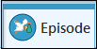

You will notice there are some different activities available for specific documentation for pregnancy.



The support staff have already roomed the patient and have created the Pregnancy Episode for you.
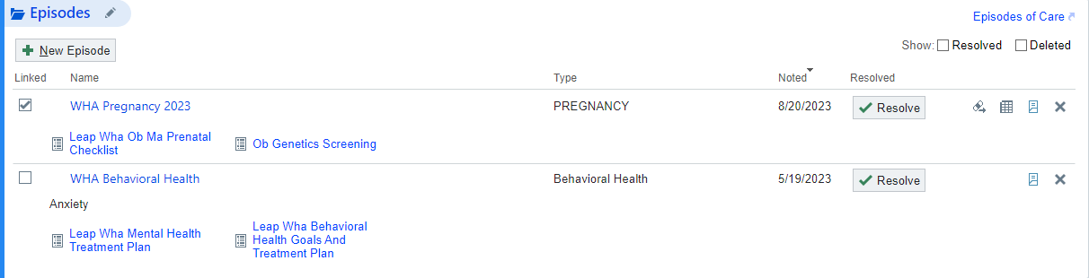
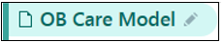

Care Model for the patient. This patient is noted Traditional. Ours was not filled in during the rooming process, so we will do that now.

- Click the Selection Tool to open the list to choose from.
- Click Traditional.
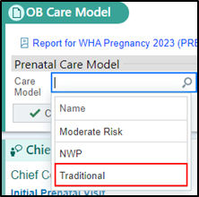
- Click Close to save this information.

The reason the patient is being seen – Initial Prenatal Visit



Vitals that have been documented by clinical support team.

Take a moment to review what has been entered here by your support staff and update as applicable.

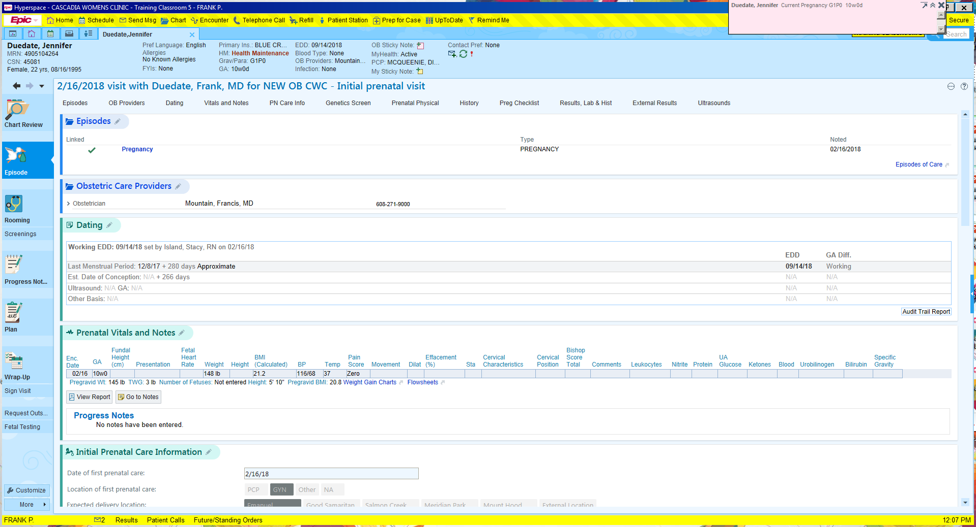

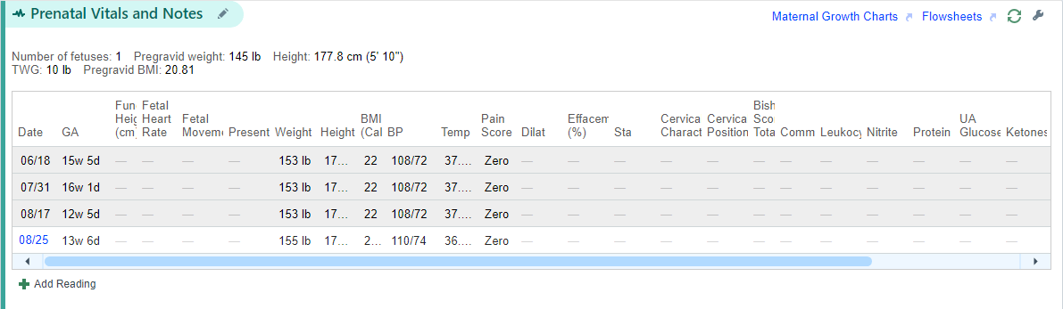
- Click the hyperlink to begin documenting.
- Fundal Height: 13
- Fetal Heart Rate: 140
- Cervical Characteristics: Firm
- Cervical Position: posterior
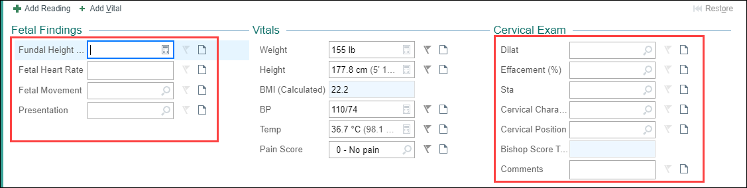

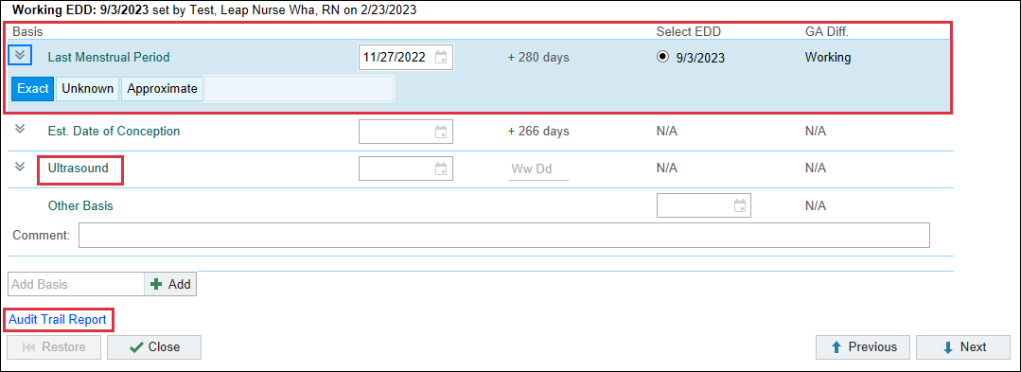
The Audit Trail Report link is available to view the reason for changing an EDD. (Located on right)

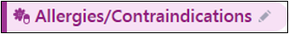

This has been reviewed by the clinical support team.

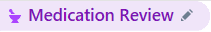

This has been reviewed by the clinical support team.

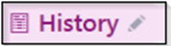

This is where the patients past medical, surgical, family, OB and social history can be updated. You clinical support team has already reviewed this with the patient and made any necessary updates.
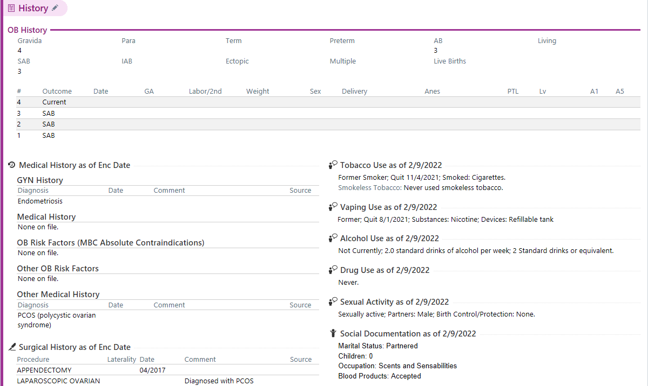

- Complete the section that fits your patient’s gestational age.
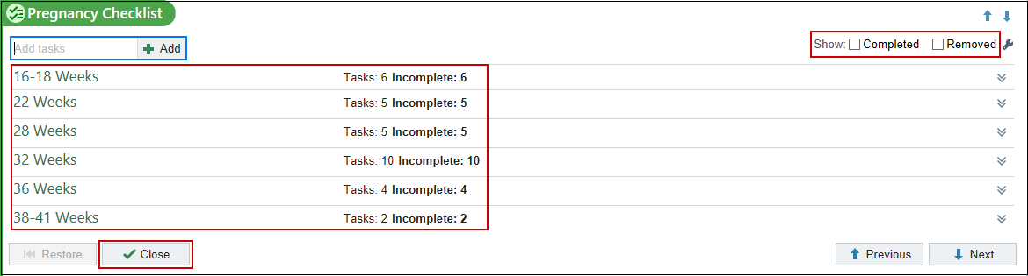

This is the patient’s Edinburgh Depression Scale Score. If it is above 10, it is recommended that patients have a consult with a Behavioral Health Clinician.
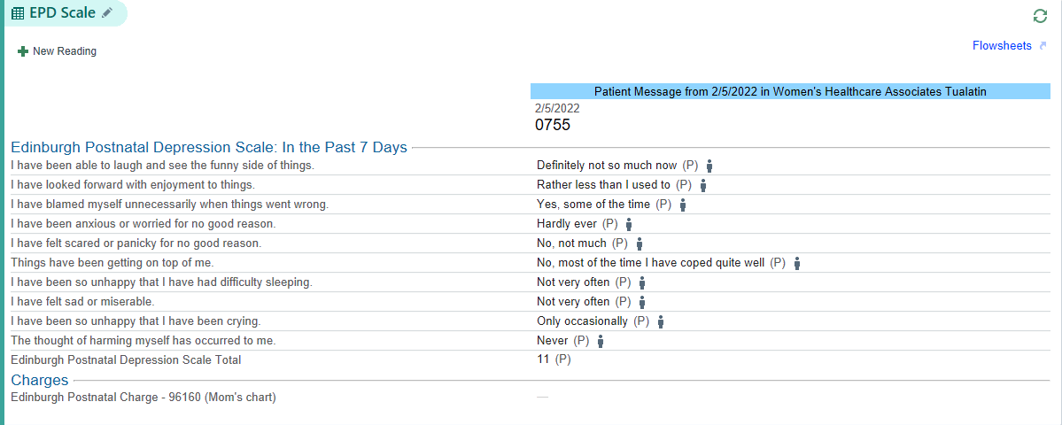

Your staff has completed this section and there is nothing for you to do here
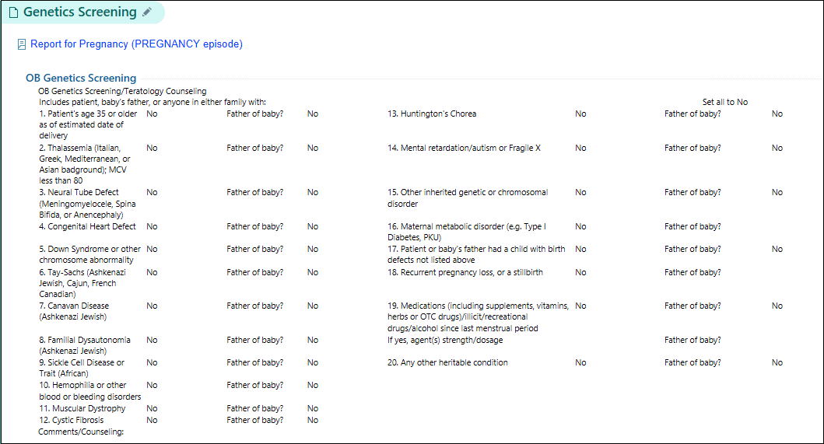



The only labs visible here are those that result from WHA’s Orchards or a Legacy lab. Prenatal labs are visible by trimester. There is nothing to show now, since this is her initial visit.

The patient has brought in documentation from an outside lab showing a positive result to a pregnancy blood test.

- Click New Reading button. 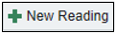
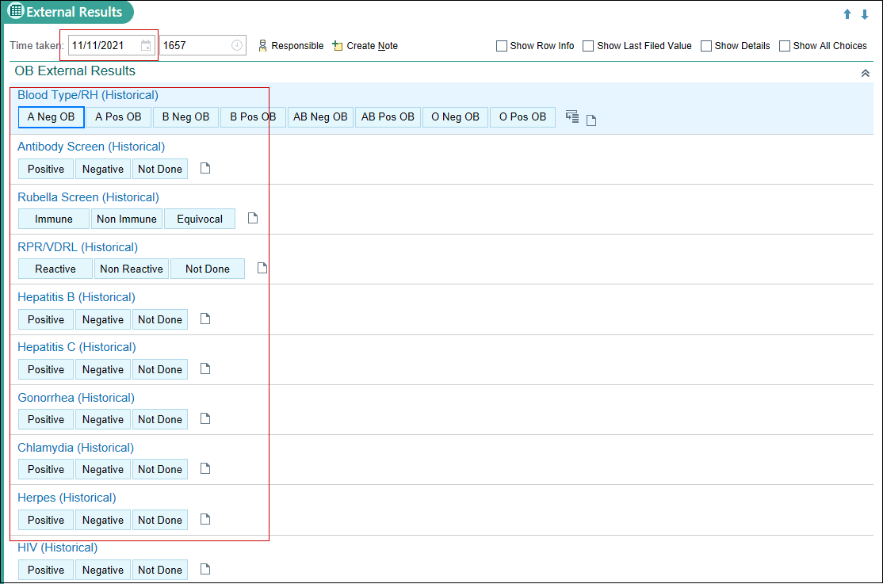
- Result was done 1 week ago, In the Date field, type: w-1.
- In the Labs other section, type in HCG – Serum.
- Add Comment of 13,000.
- Click Close button.
  - Repeat if necessary to show appropriately in flowsheets.

This Visit Activity:

In the This Visit activity, finalize your documentation from this centralized location.

Now you will place an order for any medications that will be prescribed. In this situation, let’s give the patient Diclegis and place some routine OB orders. There is a WHA SmartSet for Return OB Visits. Let’s utilize this feature for the orders we need to place.

- In the Search for new SmartSet box, type: WHA OB
- Double click the WHA OB Return Visit SmartSet
- Click the Open SmartSets button.
- Click on Diagnoses and check the box next to Hyperemesis gravidarum, mild, before 23rd week [O21.0]

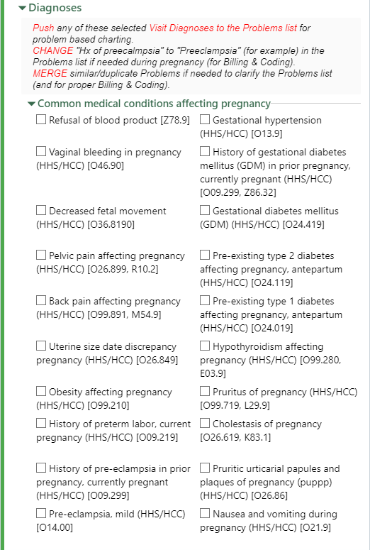
Second Trimester Anatomy Ultrasound orders should also be placed at the 12 week OB Workup. Use the Ultrasound section to select the appropriate order

- Go to 2nd Trimester: click the circle next to ROUTINE fetal anatomy survey.
- Scroll to the Medications section of the SmartSet.
- Check the box next to Diclegis.
- To satisfy the hard stop click the hyperlink for the Diclegis order.
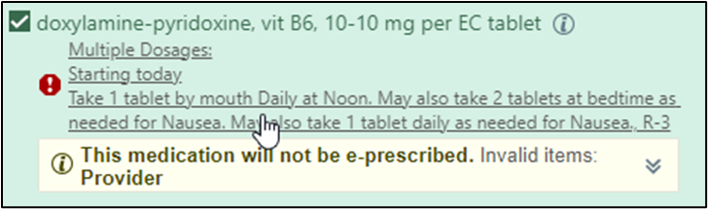
- Fill in the Quantity: 30
- Refill: 3
- The Class should be set to Normal so it is e-prescribed to the pharmacy on file.
- Click Accept to save this information.
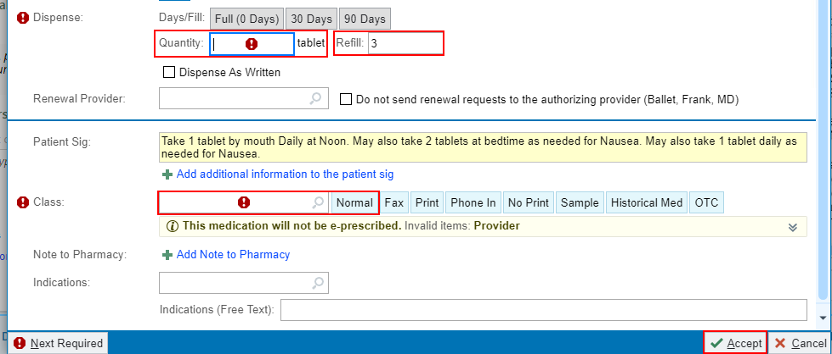
- Click Pend at the bottom of the SmartSet activity.

This will allow all orders to be signed at the same time when the clinician is ready.

Now, the order for the NIPT needs to be placed.

- Click the Preference List button
- Click Labs.
- Click Genetic Labs.
- Check the box next to NIPT – External.
- Click Accept.
- Click the Dx Association button in the Unsigned Orders activity.
- Some of the orders will be automatically associated with the correct diagnoses due to the use of the SmartSet. Since the Diclegis was not, we need to associate it with the Hyperemesis gravidarum code. Check the box to associate.
- Associate the OB Panel and Chlamydia & GC orders with Encounter for other specified antenatal screening [Z36.89]
- Associate the NIPT order with Encounter for antenatal screening for chromosomal anomalies [Z36.0]
- Click Accept.

Before clicking Accept on the Select Pharmacy window you will need to verify the correct pharmacy. Camille states she has moved and now picks up her prescriptions at Fred Meyer in Tualatin.

- Click the Pharmacy hyperlink at the bottom of the Unsigned Orders activity.
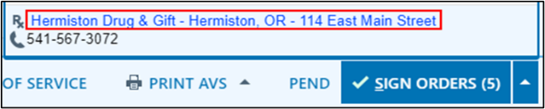
- Click the star to un-favorite the Hermiston Drug & Gift, then click the X to delete it.
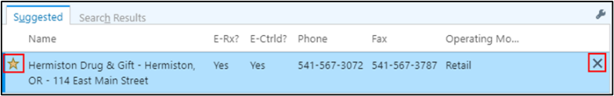
- In the Name field, type Fred Meyer.
- In the City field, type Tualatin.
- Uncheck the box where it says Patient’s and clinic’s nearby ZIP codes.
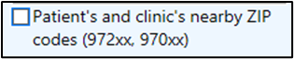
- Enter the State.
- Click Search.
- Patient verifies it is located on SW Martinazzi Ave., click the star to add to preference list.
- Click Accept.
- Click the Sign Orders button.
The Select Pharmacies window opens.
- Ensure the correct pharmacy (Fred Meyers) has the blue checkmark, then click Accept.
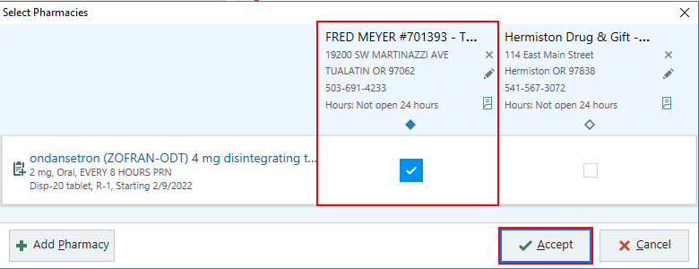
Now, we need to add the Hyperemesis gravidarum diagnosis in the Visit Diagnoses activity to the Problem List.

Patient is here for her initial prenatal visit; when you document in the A&P on the Problem List it will move it to the visit diagnosis section.
- Click the green plus in the PL column to add Hyperemesis gravidarum, mild, before 23rd week to the Problem List if you wish do document an assessment & plan under this problem.
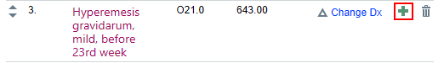

Document information about the pregnancy under the Current Assessment & Plan.

- Click Pregnancy on the problem list
- Clicking the Details hyperlink with a pencil next to it allows you to review the problem and make changes when needed.
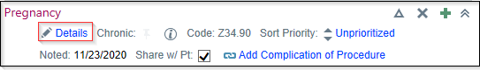

Make sure this problem is linked with the Episode created. This will make this problem drop off the current problem list when it is Auto Resolved after delivery.

- Click the checkbox to link the problem with Pregnancy Episode if it is not already checked.
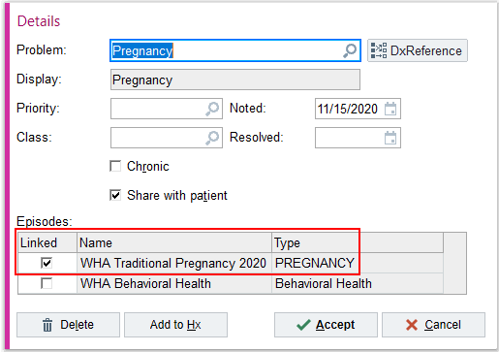
- Click Current Assessment and Plan Note to document your plan for the patient
- Type: .whaapob12
- Use F2 to help complete your documentation.
- Click Accept.
Select a specific diagnosis window opens.

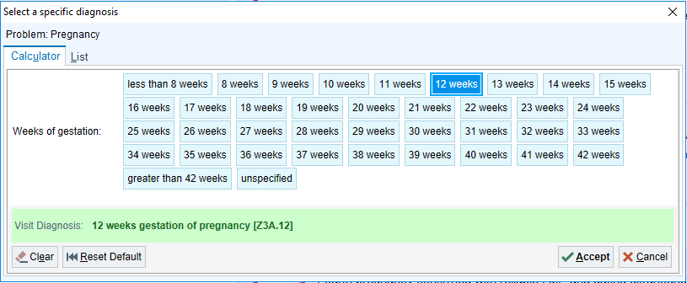
- Update with the correct gestation, reference the storyboard.
- Select 12 weeks
- Click Accept.
- You will want to assign the Pregnancy as the Primary diagnosis.
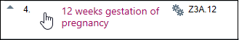
If you added Hyperemesis to the Problems List and wish to add an A&P, follow the below steps. Otherwise, continue to Wrap-up activity.

- Click Hyperemesis gravidarum, mild, before 23rd week.
- Click the Details hyperlink with a pencil next to it.

Make sure this problem is linked with the Episode created. This will make this problem drop off the current problem list when it is Auto Resolved after delivery.

- Click the checkbox to link the problem with Pregnancy Episode if it is not already checked.
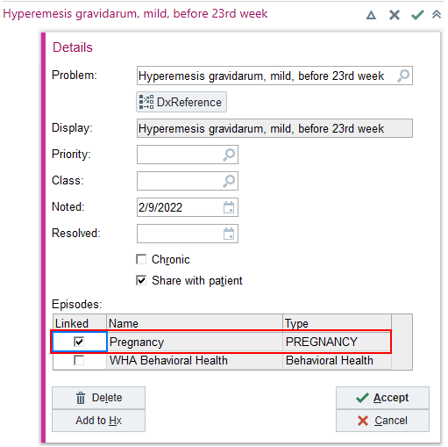
- Click Accept.
- Click Current Assessment & Plan Note.
- Document your A&P. Type: Discussed nausea and vomiting. Disrupting patient’s normal ADLs. Prescribed 4 mg Zofran.
- Click Accept.
- Click Mark as Reviewed.

Now it’s time to “Wrap-Up” the Visit.

The Pregnancy Checklist will automatically attach pregnancy information when tasks are completed. You can still add other information as needed.

- Go to Patient Instructions.
- Click the Clinical References hyperlink or search for whatever document you’re looking for.
- Select Pregnancy: Your First Trimester Changes by checking the box next to the document.
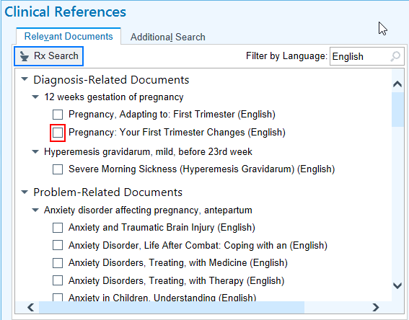
- If you need to edit these, click the Edit hyperlink in the Attached References section.
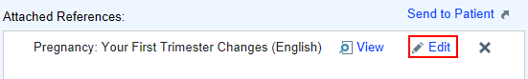
Document the service code for an Initial Prenatal Care Visit.

- Select from the pre-built code, Initial Prenatal Care Visit [0500F].
Discuss that for good prenatal care, you would like to see her again in 4 weeks.

- Go to Follow-up.
- Return in: Click 4 weeks.
- For: click Routine Prenatal Telehealth Visit.

You want to have the front desk staff schedule her follow-up in 4 weeks.

- Click Expand link (bottom right of section)
- Click the Checkout note and type a note to front desk staff when patient checks out. Patient to schedule appointment in 4 weeks for routine prenatal telehealth follow up.

Document that the patient declines the AVS.

- Click Pt Declines AVS .

Now go back and update your Progress Note.

Progress Note Activity:

- Click the Refresh button.
- Press F2 – accesses first SmartList that needs to be answered
- HPI:
  - The clinical support team has entered a Smartphrase in the HPI.
  - You can add to this documentation or remove it and add your own documentation.

Document the Review of Systems.

- Click the ROS Button.

Document the Physical Exam

- Complete your documentation of findings on all clinically relevant tabs.
- F2 or Scroll to the bottom of your Note.
- Complete the Chaperone Documentation.
- Select MDM for your coding attestation.

Pregnancy Wheel Activity:

- Click the additionall activities  button to view the additional activities Epic has to offer.
- From the menu of options, select Pregnancy Wheel.
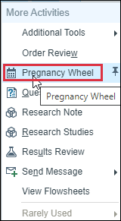
- Click the pin cushion to pin it to the activity tabs for future use.
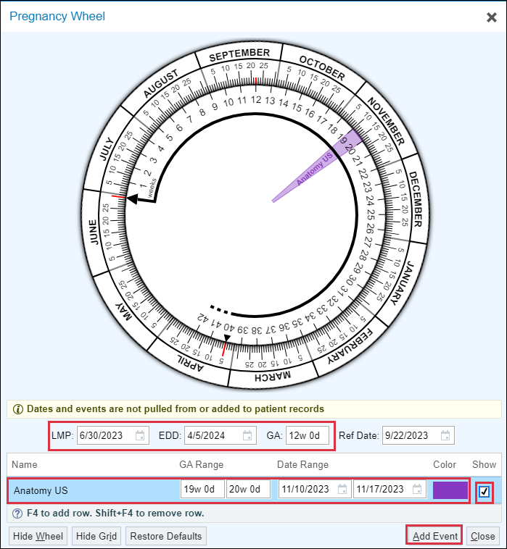
- Click Add Event, to add things on this wheel.
- Suggestion, when the patient will need Tdap or Rhogam, Expected Ultrasounds or tests.
- Click Add Event button
- Type in Name; GA Range to appear & Show checkbox.
- Anatomy US – 20w – 22w
- Rhogam – 28w
- Tdap – 28w – 32w
- Pack Bags – 36w
- Click the Sign Visit activity

Exercise 2: Return Prenatal Visit / NST Documentation

Scenario: Odette called in earlier stating she was concerned about decreased fetal movement. The patent is here to have a Non-Stress Test (NST) performed in clinic.
Use some of the reporting tools to get up to speed with your patient.

- Click the WHA Pregnancy Episode on the bottom report pane
- Double click to open the patient’s visit encounter.
- Click on Start Review located at the bottom of the patient’s Storyboard.
- Click Mark as Reviewed.

Progress Note Activity:

- Click Edit in the Prenatal Care Return Visit note.

The note is mostly complete as it is constructed incrementally during the patient’s appointment.

- Click the Refresh button.

Episode Activity:

It is a good idea to verify that this section has been completed when reviewing charts for patients at later stages of gestation to ensure proper documentation. Odette’s is blank, so we will practice filling it in now.

- Go to the Pregnancy Overview & Plan.
- Click the section header to open the section.
- Planned Anesthesia: Spinal
- Circumcision Requested: Provider Performed
- Plans for Cord Blood: Do Not Collect
- Planned Adoption: Not Applicable
- Planned Birth Control: IUD – Mirena
- Click Close.
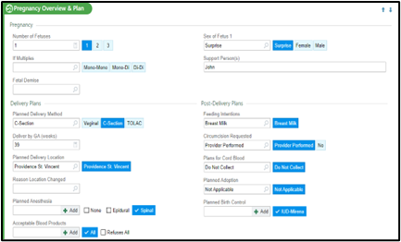

You would document Fundal Height, Presentation, etc. You are not adding notes to the lower section of this activity since you already have a progress note started.

- Go to Prenatal Vitals and Notes.
- Click the appointment date’s hyperlink.
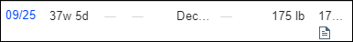
- Document Fetal Findings.
  - Fundal Height: 37
  - Fetal Heart Rate: 140
  - Fetal Movement: Decreased (already documented by support staff)
  - Presentation: Breech
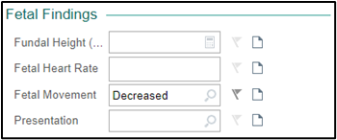
- Click Accept.
- Go to the Prenatal Checklist

For past tasks that are incomplete, we are leaving them alone. But the patient is 37 weeks. We will check to see if there are any tasks needing to be completed at this visit.
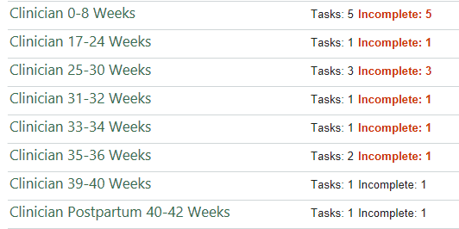
There are no tasks assigned for 37 weeks.

This Visit Activity:

All information is up to date on this list. If you wish to review previous assessments and plans related to this patient or problem, select "Pregnancy" and click on the View All Notes hyperlink located in the lower right corner of the problem section.

- Go to the Problems List.
- Click Pregnancy to open for documentation.
- Click Current Assessment and Plan to document your plan for the patient
- Type: Doing well. Good fetal movement during NST.
- To view past documentation, click
- Click Accept.
- Once you have added an A&P, it will automatically add this to the Visit Diagnosis section.
  - Remember to add current weeks to the specific diagnosis window.
- Also add an A&P to Hypertension complicating pregnancy in third trimester, such as: Denies headaches, blurry vision, and RUQ pain. Pt still taking BP readings at home. All normal. Continue taking Lovenox as prescribed.
Patient was scheduled for a Non- Stress Test (NST) due to her Gestational Hypertension, but she also mentioned to the MA that she has not felt the baby move much today. This NST was performed prior to her in-person visit.

- You may choose to add the Decreased Fetal Movement to your Problems and complete an A&P for this problem.
- You may instead choose to document the decreased fetal movement under your Hypertension complicating pregnancy in the third trimester or the Pregnancy problem.
- Click Mark as Reviewed.

Now take some time to review the NST strip prior to seeing the patient. You can review this information and document your impression.
Let’s go to the Fetal Testing activity tab now.

Fetal Testing Activity:

Navigate to the Fetal Testing activity and finish documenting the reading by clicking the blue hyperlink under today’s date.
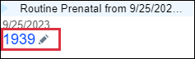
- Add the necessary documentation from the strip.
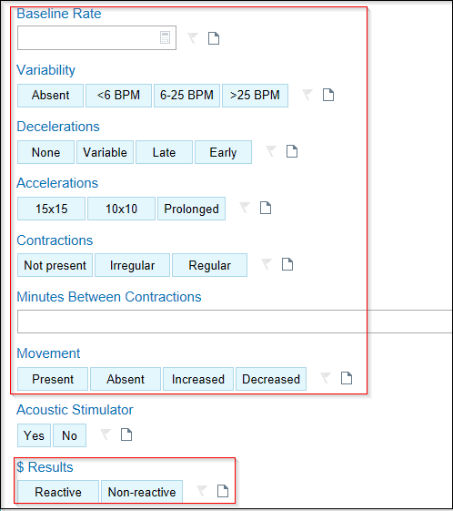
- $ Results: select Reactive.

The Charges will drop when the form is complete and results have been documented.

Go to the Charge Capture section using your navigators.

- Once you’ve marked Reactive/Nonreactive, a HC (hospital charge) for the NST will automatically drop. If you notice a HC Non-stress Test, remove it by clicking the X.
- In the Charge Capture – Delete Charge box, click Delete.
- Enter a PR Non-Stress Test (code: 59025) charge if not already done using the Search for new charge search box.
- Click Accept.
- Click the Star next to the Charge to Favorite it.
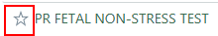
- Change the Display name to NST.
- Click Accept.
- Update Charges: Yes.
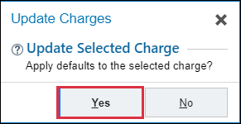
- Click the pencil next to the charge to open.
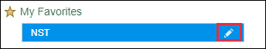
- Associate the appropriate diagnoses, hypertension affecting pregnancy and decreased fetal movement.
- Click Accept.
Return to your progress note to bring in documentation.

Progress Note:

- Place your cursor in the Progress Note and press F2 to select options to compete your documentation.
- Update any additional comments with the wild card *** with your plan for the patient’s ongoing NSTs and BPPs.

Remember you can go back and finish your note at your convenience.

You decide with Odette to schedule a cesarean section at Providence St. Vincent within the upcoming weeks and need to submit a Surgery Case Request.

- Click Add Order from the visit taskbar.
- In the Search for new order field, type Case Request and press Enter.
- Double click on WHA Surgery Case Request order to add it to your shopping cart.
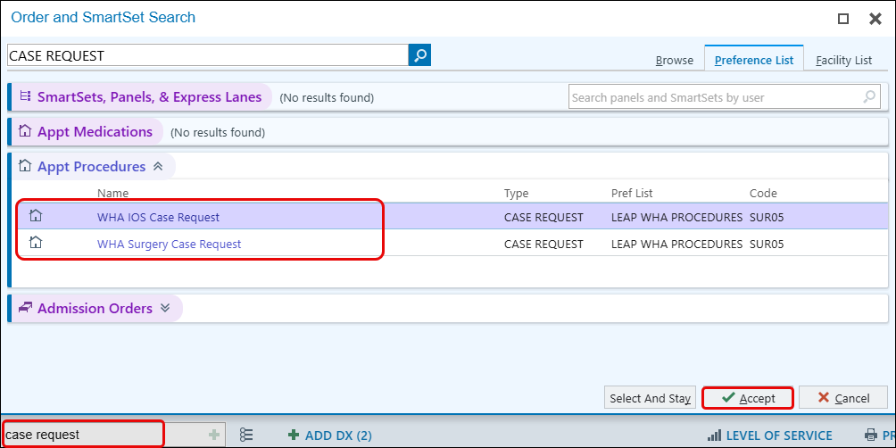
- Click Accept.
- In the Sign Orders in the visit task bar, click on the surgery request order.

Let's begin by adding a provider to view the available hospital locations for your selection.

- In Panel 1, Add a provider. Use Greg Eppard or Gary Burgoine for this exercise.
- Location: select EXTEERNAL/UNSPECIFIED, as the scheduled cesarean section will take place at Providence Hospital.
- Add procedure: Cesarean Section
- Click Accept.
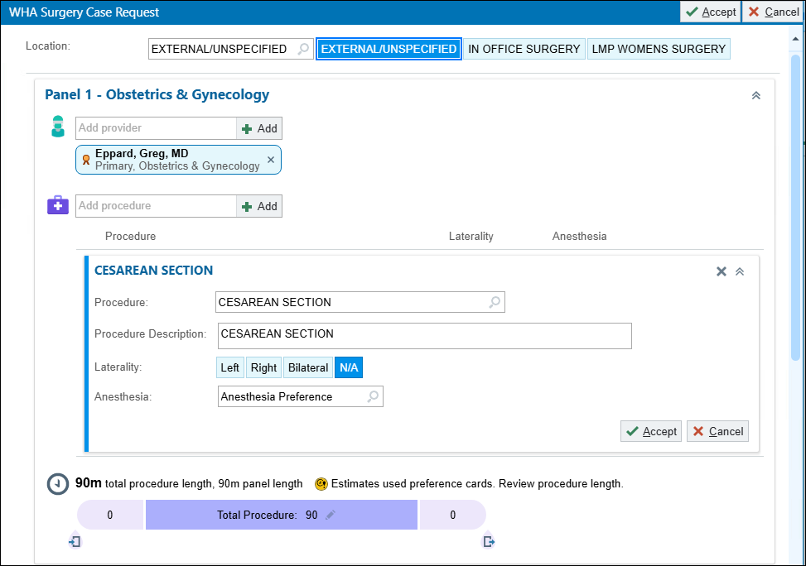
Document in the fields below as appropriate and remove any unnecessary documentation in the comments box at the bottom of the request. All request go to the surgery scheduler pool for your site. Keep in mind that the request also goes to our Billing Team and the Financial Counselor Team prior to the patient getting scheduled.

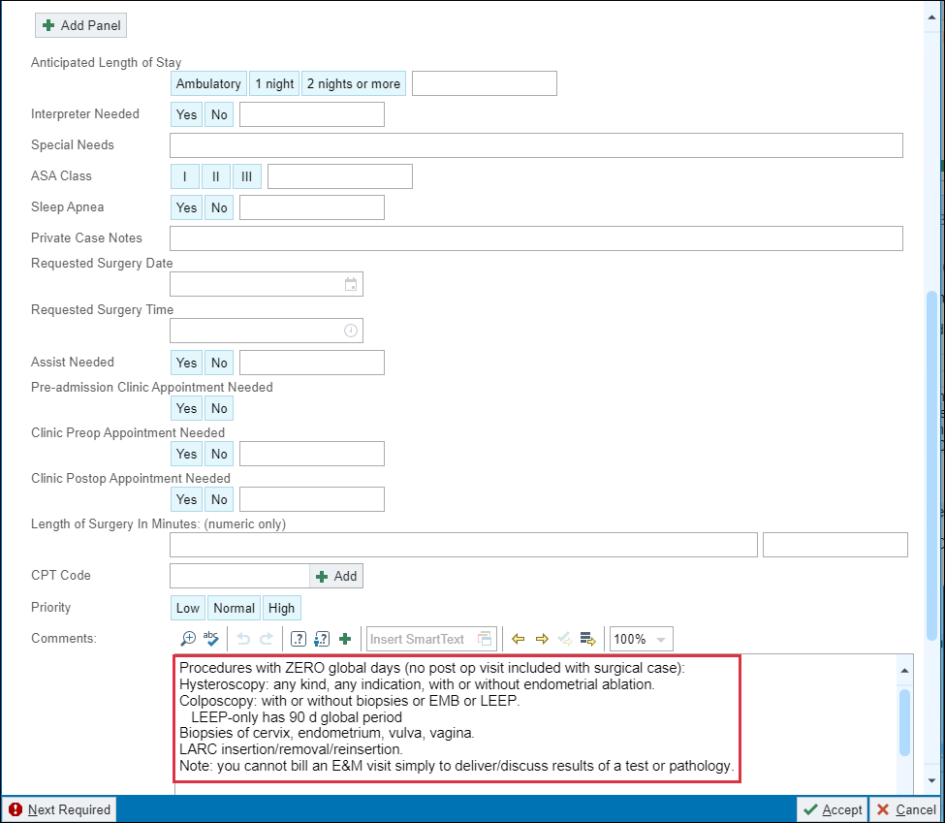

Note: Once you have sent this request, changes to this form can only be made by your surgery scheduler team. You will need to send a staff message to the surgery scheduler pool with any changes you wish to make.

- Click Accept when complete.

Time to finish up the visit.

Notice that your clinical support team has added standard WHA pregnancy specific patient instructions for you.

This is Odette’s first Non-stress test and you want to provide her with some additional education. You can search for materials available for NSTs.

- In the SmartText field, type NST and press Enter.
- Select Stress Test, Non-stress and Contractions.
- Click Accept.

Discuss that you would like to see her again in 1 week.

- Return: 1wk
- For: Routine OB In-person Visit.
- Click the wrench to add to quick selections for other patients.

You have completed your note and documentation for this visit. Now it is time to sign the visit. Make sure you go back and click the refresh button in your ‘Progress Note’ one last time.

Progress Note:

- F2 or Scroll to the bottom of your Note.
- Document a plan for the patient regarding the NST.
- Choose either TIME or Medical Decision Making (MDM) criteria.
- Complete the Telehealth attestation by pressing F2 and choosing Clinic Visit.
Document the level of service located on the Visit Task bar and associated with a global pregnancy.

- Select the appropriate level of service.
- Click the 1 Unsigned Order button
- Click the DX Association button.
- Associate the Group B Strep order with the appropriate code.
- Click the order to satisfy the rest of the hard stops.
- Specimen Source: Vaginal/Rectal.
- Allergic to penicillin?: Check the Storyboard for Allergies. She’s allergic to amoxicillin, click Allergic to Penecillin.
- Click Sign Orders (1)
- Click Sign Visit.

Exercise 3: Postpartum Telehealth Visit

Scenario: Pamela is scheduled today for her 3-week postpartum telehealth visit.
First review some of the reporting tools to get up to speed with your patient.

- Click the Pregnancy Episode on the bottom report pane

Note the delivery information has been updated.

- First, double click the patient’s visit to open for documentation.

When you open the encounter, you will be in Pre-Charting.

Progress Note Activity:

For this telehealth visit, notice that your support team has started a note template for you.
You will complete your progress note, ROS and Physical Exam later in this exercise.
When you have the patient on the video, click Start the Visit

- Click on Start Review located at the bottom of the patient’s Storyboard.
- Click Mark as Reviewed .

Episode Activity:

Since Pamela is a Postpartum Patient, your MA will have enter information into the Postpartum Info section and documents EPD scale answers in her chart. Review this information as it will be helpful during the visit.

Rooming Activity:

- Go to Chief Complaint.
- Click on the pencil.
- Type: Post-Partum Care in the white search box or use the preset speed button.
- Click Close.

This Visit Activity:

Check to see if her problems list is up to date.

Now is a good time to resolve some of her pregnancy problems or add them to her Hx if applicable.

- Click Search for new problem box and type: Postpartum care.
- Choose Postpartum Care and Examination.
- Click Accept.

Make sure to link this problem with the Episode created. This will make this problem drop off the current problem list when it is Resolved.

- Click the checkbox to link the problem with Pregnancy Episode.
- Click Accept
- Click Current Assessment and Plan to document your plan for the patient
- Type note: Delivered [insert date of delivery], NSVD with sm laceration on perineum, healing well. Discussed IUD insertion at her wellness apt. in 5 wks.
- Click Accept.
- Have the patient return in 5 weeks for a well women’s exam and IUD insertion.

Now go back and update your note.

- Click the Refresh button.
- Press F2 – accesses first SmartList that needs to be answered
- Chief Complaint is seen.
- HPI:
  - History of present illness, including ROS and history if applicable.
Document the Review of Systems.

- Click the ROS Button
- Add to the fields if appropriate.

Document the Physical Exam if applicable to the visit.

- Complete your documentation of findings on any clinically relevant tabs.
- Go back to your note and press F2 to access the WHA Telehealth Attestation variable.
- Double click the Video Visit option.
- F2 or Scroll to the bottom of your Note.
- Choose either TIME or Medical Decision Making (MDM) criteria.

Each Telehealth appointment needs an attestation. While you may be billing for MDM, it is important to also document the number of minutes spent in Medical Discussion with the patient if the visit takes place via phone.

- Press F2 to access the SmartList for the telehealth attestation.
- Double click to select the appropriate selection to invoke the attestation.
  - For this appointment, because we were able to connect via video, select Video visit.
- Select GlobalPP for level of service.

You have completed your note and documentation for this visit. Now it is time to sign the visit. Make sure you go back and click the refresh button in your ‘Progress Note’ one last time.

- Click the Sign Encounter.

Exercise 4: PP8/Wellness Exam and IUD Visit Documentation

Scenario: Paula’s appointment notes say she is coming in for an 8-week postpartum/Wellness and IUD. First review some of the reporting tools to get up to speed with your patient.

- Notice the result for the Urine Pregnancy order is Completed.

Double click to open the patient’s visit encounter.

- Click on Start Review.
- Click Mark as Reviewed.

Progress Note Activity:

- Click Edit to document in the existing Progress Note.

Since a POC pregnancy test was completed for the patient’s IUD insertion, this can be documented in the Note.

- Under HPI SmartBlock type: .THISVISIT
- Review the Depression Screening information in the Note.

Paula’s score shows Moderate depression according to the table, based on her score of 12 in the PHQ9. Her Suicide Ideation is Negative.

- Press F2 or click to access the WHA Depression Interventions SmartList.

Since Paula is within the six-month postpartum period, she is eligible to access services from WHA’s Behavioral Health Clinicians. She has accepted this support when offered. A referral will be processed at a later time.

- Single click the box next to Medical therapy discussed and/or offered today, then right click to save the selection.
Review the patient’s SUD Screening. She does not screen positive. Utilize the WHA SUD Interventions SmartList to document.

- Press F2 or click to access the SUD Interventions SmartList.
- Single click to check the box next to N/A, patient did not score positive for substance use screen, then right click to save selection.

Document the Review of Systems.

- Click the ROS button to quickly access the documentation for this section.
- Click the Physical Exam SmartBlock.
- Click the Breast tab.
- Begin making selections.
- Click the plus sign for tenderness of left breast.
- Hover over and start typing to add findings comment.

Now let’s complete your documentation of her physical exam using other pertinent exam tabs.

- Abd – Document using your clinical judgment.
- GU – External, Internal, Pelvis Floor, Anus/Perianal if applicable.

I need to document my procedure notes from the IUD insertion using Procedure SmartBlock.

- Click on the Procedure SmartBlock located at the top of the NoteWriter or access it from the top of your note template.

Support staff will often fill out the Consent section.

- For this exercise, complete the Consent section.
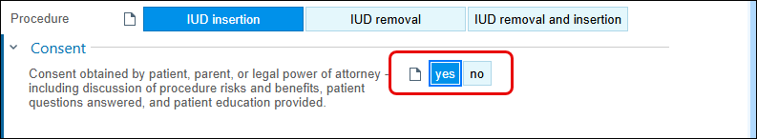
Go to the Pre-procedure Section.

- Negative urine pregnancy test: Yes
- Premeds: Ibuprofen, use the paper to add comment: 600 mg.

Complete Procedure Section documentation as applicable.

- Immediately prior to procedure a time out was called: Yes
- Pelvic exam performed: Yes
- Uterus position: Midline
- Speculum placed in vagina: Yes
- Cervix cleaned and prepped: Yes
- Tenaculum/Allis/Ring Forceps applied to cervix: Yes
- Anesthesia used: No
- Uterus sound depth: 6
- Cervix dilated: No
- IUD Type: Mirena
- IUD inserted without complications: Yes
- Strings trimmed to (cm): 2
Post-procedure section:

- Patient tolerated procedure well: click Yes
- Ultrasound to check position of IUD: No
- Intended removal date: 5 years
Before moving on, complete the remaining variables in your note template.

Paula has requested to have a chaperone present as seen in her Storyboard. This needs to be documented in the Note.

- Press F2 or click the Chaperone Documentation SmartList.
- Double click Accept.
- Document the name of the chaperone in the wildcard that has pulled into the note.

This Visit Activity:
Paula is here for her wellness, pap, and to discuss IUD for birth control after her recent delivery.
- Type well woman and press Enter
- Select Well woman exam (1st on the list)
- Click Continue to A & P and document your plan for the patient.

You can choose to document the IUD insertion under Well Women Exam, or you can add Contraception Management to the patient’s problem list to document the IUD insertion.

- When finished, click Accept.
- This will automatically add to Visit Diagnosis section.
- Click the Mark as Reviewed button.

This would be a good time to resolve any problems on Pamela’s Problem List that were related to her pregnancy.

- Hover over the X next to the problem you wish to resolve to view the list of choices.
- If there is a problem that you would like to add to Pamela’s History, select Resolve & Add to Hx or Resolve.
What was the purpose of the visit today?

- Change the Primary diagnosis to Well woman exam.

Now place some IUD specific orders. SmartSet make suggestions on specific documentation, different types of orders, patient instructions, level of service, and follow up recommendations. For this situation, look for a system SmartSet for IUD.

- In the Search for new SmartSet field, type IUD.
- Press Enter.
- Select WHA LARC SmartSet.
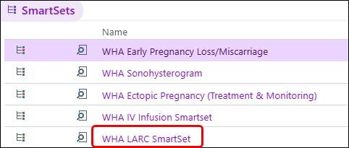
- Click Accept.
- Click Open SmartSet button.
- Uncheck the Reason for Visit. Support staff has already documented this in the rooming process.
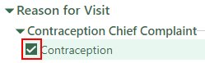
- Go to the Orders section and expand IUDs
- Select Encounter for IUD insertion
- From here, you may choose to add this to the patient's problem list now to streamline the process later.
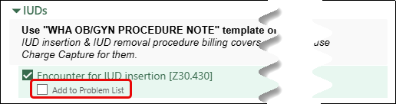
- Select both Mirena orders. [One adds to the MAR the other is for the Meds list]
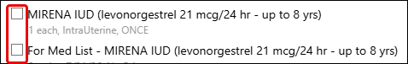
- Click the arrow to expand Patient Information, select Mirena FAQ After Insertion.
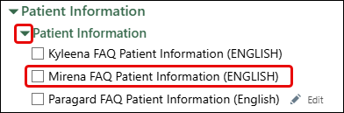
- Follow Up (as needed) will be selected by default.
- Uncheck the circle.
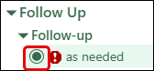
- Click the Sign.
- Associate the diagnoses with your IUD orders.



- Click Accept to open the SmartSet.
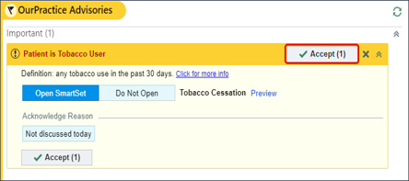
- Complete Tobacco Cessation SmartSet and Sign.

You will want to place any appropriate orders for the pap using the Preference List icon on the visit task bar.

Make sure to associate it with the Cervical Cancer Screening diagnosis code and sign the order.

It is time for me to “Wrap Up” this visit.

The IUD Insertion Patient Instructions were entered in from the SmartSet selection. Support staff have already pre-loaded education about staying healthy.

You discussed with patient that she should return in one year for a well-woman exam, unless her test results indicate abnormalities or she experiences any issues with her IUD implant.

Now preview the AVS.

- Click the AVS Preview and Options to make changes to the Font Size or language as needed.

Document the level of service given to the patient.

- Select the appropriate level of service.
  - In this scenario you will choose ESTPREV18 for the LOS as your procdoc drops the necessary charges for the procedure.

You have completed your note and documentation for this visit. Make sure you go back and click the refresh button in your ‘Progress Note’ one last time.

- Click the Sign Visit.

Click the X next to the patient’s name to close the chart until the IUD documentation is completed by support staff.

Notice the med icon on the schedule. This is a visual que that EPIC uses to indicate the IUD needs to be add to the MAR.

Module 7: IN BASKET Workflows

Exercise 1: Access the In Basket Activity

There are multiple ways of accessing In Basket messages.
1> In Basket workspace tab (Top of screen) 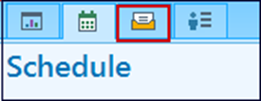
Access all messages and activities.
2> In Basket Card Viewer (Far right side of screen) 
Access Results, Rx Refills, and Patient Calls folders.
3> In Basket tool bar (top right of screen)

Reflection of current folders statuses in your In Basket

Let’s click on the InBasket workspace tab to view this work.
The most efficient way to access any folder specifically is to click on the name of the folder in the In Basket toolbar.
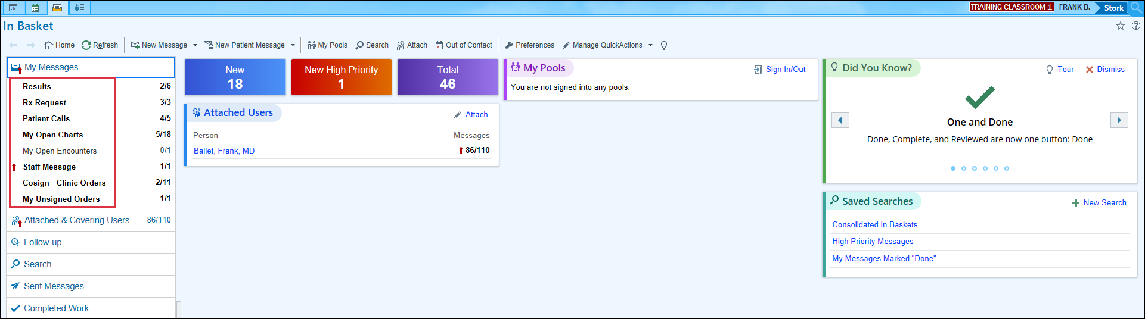
Before you begin looking at the various task folders, let’s take a closer look at some functionality and navigating this workspace first.

Exercise 2: In Basket Functionality Demo.

Let’s begin by browsing the Home screen to get an overview of your work before diving in.

First notice, new activity buttons specific for work in the In Basket.
- Home – The main screen to help you stay on top of tasks.
- Refresh – Manual refresh for the In Basket
- New Msg – To send a message to staff/providers.
- New Patient Msg – To send a message to patient using MyHealth.
- Attach – InBaskets that you will attach to when covering your call group clinicians.
- My Pools – As a clinician, you are not assigned to pools. This is more for your clinical teams.
Then moving over to the left side of the window….
- My Messages – 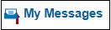
  - Current unresolved work; if there is no work to do, you won’t find the categorized folder.
- Folders – Will appear as you have tasks/work assigned to you.
  - Numbers indicate the number of new/total tasks in the folder.
At the bottom left of the activity, you see…
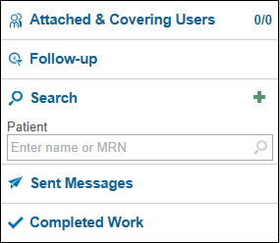
- Attached & Covering Users – List of users InBaskets you’re attached to so you can easily cover for your peers that are out of the office.
- Follow-up – Use to apply flags, postpone or add comments to your messages.
- Search – To search for patients.
- Sent Messages – Messages you have sent during the day.
- Completed Work – Everything you have done/completed in the last 30 days.

While working the In Basket in-between patients, use the buttons on your home screen to quickly jump to New or High-Priority messages.


Hover to Refresh or Close the folder.
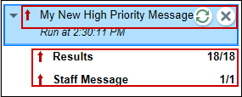

If you are looking for something specific, your Saved Searches can be seen in this activity so you can find the right messages when you need it.
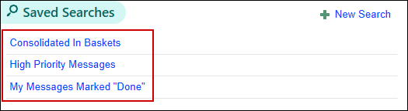

When looking for Sent Messages or Complete Work you can find those in the left Navigator.
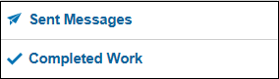

If you want to find a patient you don’t have open, use the Search in the left navigator.
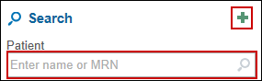
- Click the green plus for additional search options available.
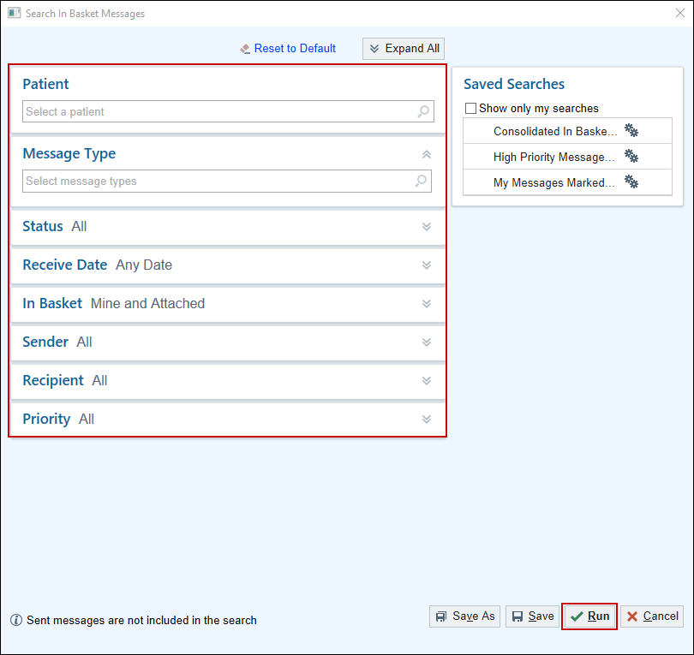

Now I will show you some of the basic functions of completing work in the In Basket.
Consistency is crucial for accomplishing tasks quickly therefore, no matter which folder you’re in, the buttons on the left of the tool bar stay put.

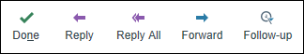
The Follow-up 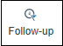 button has a few additional actions like Comments, Postpone and Flags to speed you up even more.
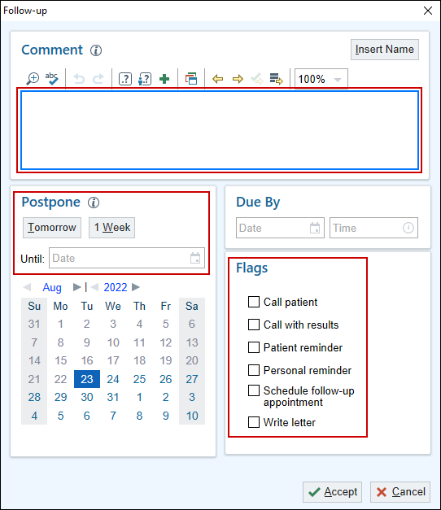
- Click the Insert Name button to add your name, date and time stamp to a comment.
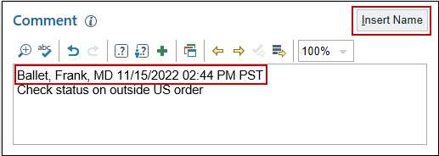

When in a folder, all messages will be listed in the first column or pane. I have a new Staff Message, because the folder & status of the message is New.

I can also see some specific information about this message, such as: Msg Date, Sender and Subject. We will talk about pool workflows here in another exercise.
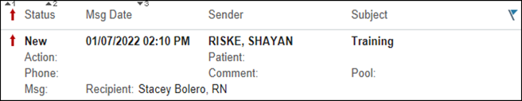

There is also a feature of Epic called “Auto Advance”. Once you have completed a message, Epic will automatically jump to the next message on the list and change its status from New to Read, saving you from having to click to select next messages.
This feature can be turned off by customizing this folder.

- Click the Wrench above the list of messages.
- Click the checked box next to Auto Advance.
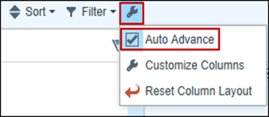
This customization must be done in every folder, but once it is done… You can “Set it and forget it”.
To the right of your screen, you see your Quick Filters as well as customizations and Help before you select on a message in the folder.
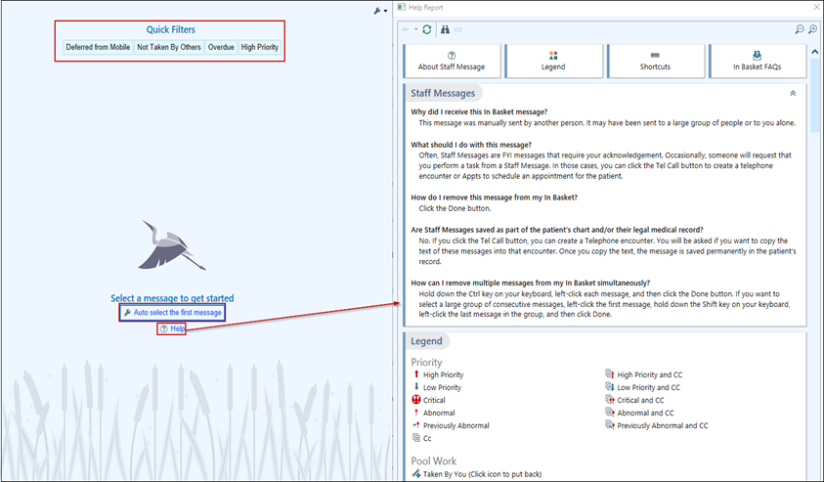
Now I will show you how to complete a message/ task in In Basket.

I will click on the Staff Message about Training.

The message itself shows up in the right pane.
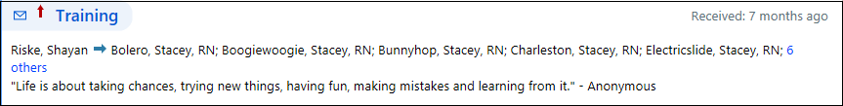
There are activity buttons specific to this type of message/ task to help you complete the work that has been assigned.
For this example, there is no more work that needs to be done, so I can “Done” it.
- Click the Done 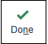 button.
The message status has changed to ‘Done’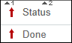.

- Click the Refresh 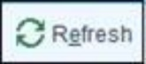 button.

Notice that the message disappears from the folder.
The folder and message disappear, saying I have no new work. This folder will come back when I have new Staff Messages assigned to me.

Exercise 3: Create Staff Message

Scenario: You ask Maria to schedule a follow-up telehealth in 4 weeks. She states her schedule is constantly changing and will only know her schedule about 2 weeks before she is due for her next visit. You will create a message and send it to the front desk pool, for someone to call and schedule the visit when the patient has her schedule.
- Click on New Msg
- In the To field: P WHA Patient Services TN
- Subject: Follow-up Visit
- Click the magnifying glass to open Patient window.
- Patient: Look at Recent Patient’s Tab to find your Maria patient.
- Notes: Please contact patient to schedule her preconception consult telehealth appointment in 2-3 weeks.
- Click on Dates or use the chevron icon to open.
- Go to Delay sending until section, and in the Date field type w+2 then press Enter.
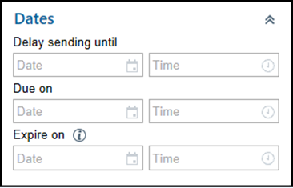
- Click Send. 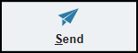

Go to send messages. Click refresh. Staff message you just created shows up.

Exercise 4: Rx Request Folder/ Rx Refill Encounter

Scenario 1: You have an Rx request from a patient named Maria who is starting Clomid. The RN Staff have begun the documentation and routed for your approval.
Rx Request folder.

- Locate and select your Maria patient message.

The message reads that she would like to begin the clomid that was discussed at her last visit. She would like them to be filled at Costco Pharmacy in Portland.
Notice the buttons above the message that are specific to medication requests
Next you will turn off a default setting called Auto Advance.

- Click the Wrench above the list of messages.
- Unselect Turn Off Auto Advance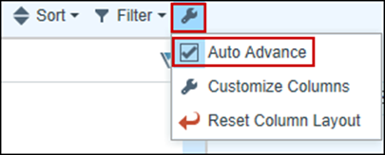.

You will now Approve this medication and send a note to your support staff.
- Click the Approve and Route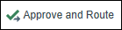 button.
- Requested Medication window opens for you to complete information.
- Dose: 1 Tab
- Frequency: daily
- Dispense: 5 tabs
- Refill: 0
- Click Accept.
- In the Recipients section, click in the search box.
- Select P WHA Advice TN POOL
- Add a Routing comment: Please call and let the patient know that the requested medication has been approved and will be filled at her preferred pharmacy.
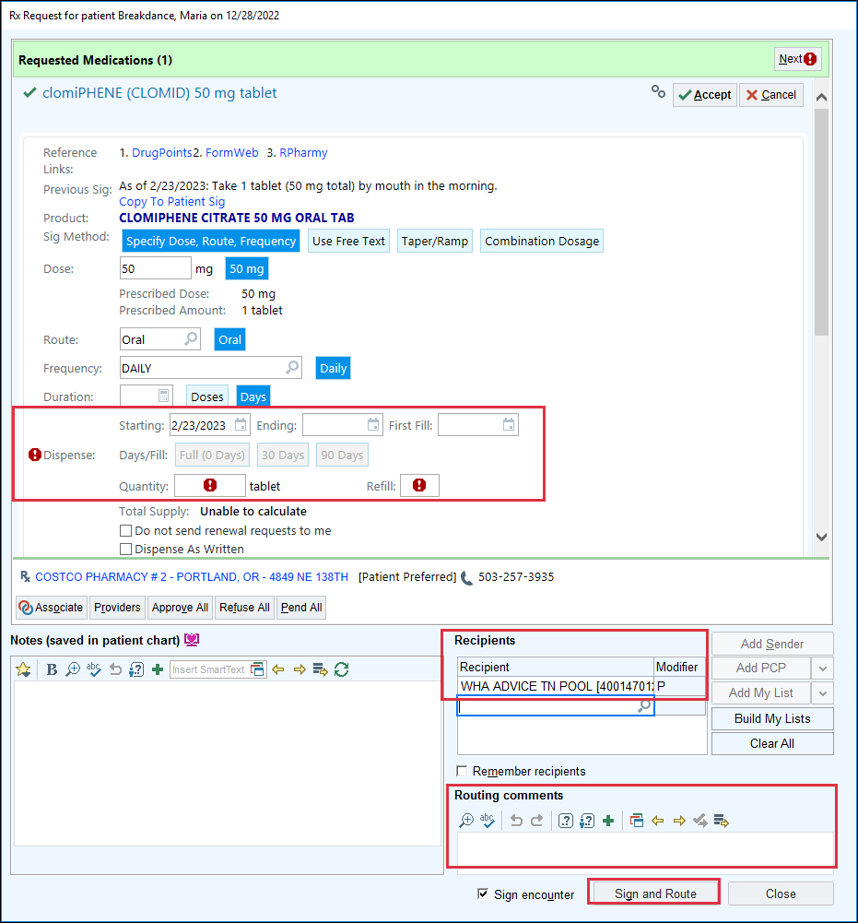
- Deselect the Sign encounter checkbox.
- Click Sign and Route button.
- A New Warnings window will open.
- Click a speed button or use the magnify glass to select from the list of override reasons.
  - When using the speed button, it will not have you click Override and Accept.
- Click Override and Accept.
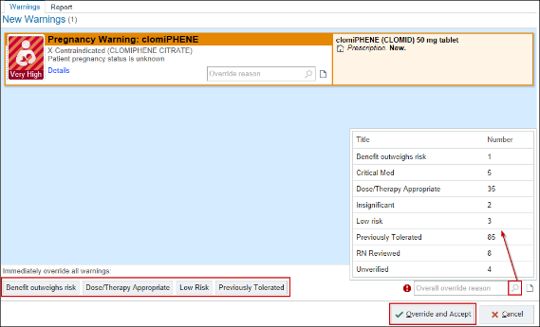

Exercise 5: Rx Request Folder/ Rx Refill Encounter

Scenario 2: You have another Rx request, this time from Gretchen for a prescription for estradiol. You will first look at the patient’s chart for specific information.
You have should have everything you will need within the report’s tools.
- Click on Last Visit report which will show the patient’s last visit with you.

You decide that you want to have a chat with the patient yourself.
- Click the Encounter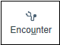 button.

Take Action Activity: 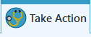

Document the outgoing call to the patient.

- Click Outgoing Call button
- Ensure that the Self and Home # buttons are selected.
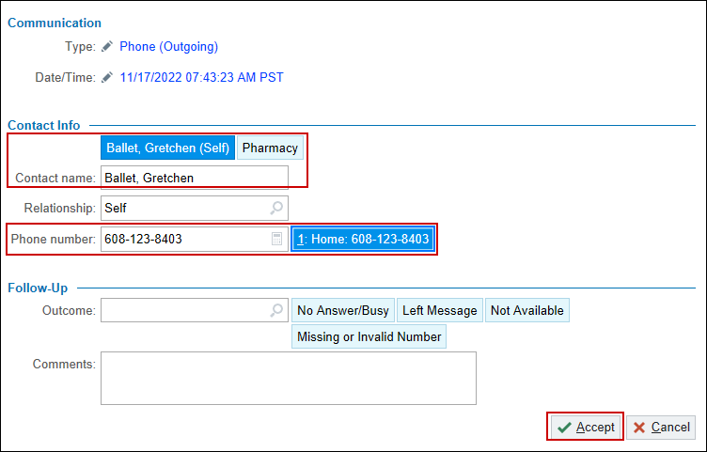
- Click Accept.

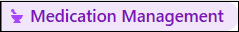

Let’s review our patient’s current medication list and open up the details using the chevron icon.
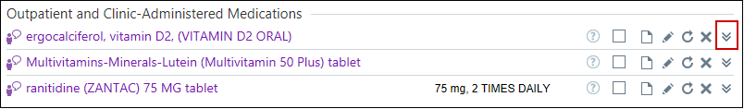
Notice in the Visit Task bar you have an unsigned order that your MA placed.
- Click 1 UNSIGNED ORDER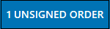.
- Single-click on the medication.
- Ensure the Dispense section is filled in properly: 42.5 g with 1 refill.
- Click Accept.
- Click DX Association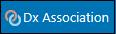 to add a diagnosis to the prescribed medication.
- Use the Search bar or click on the Problems list.
- For this example; select menopausal symptoms from the Problems drop down list and click in the box to associate.
- Click Accept.
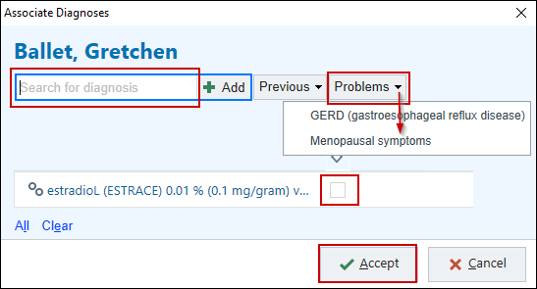
- Click Sign Orders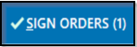.

Documentation: 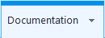
To document your note to be viewed by all staff, click the expanding button on the right side, in the middle of the screen.

- Click the Create Note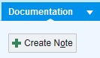button.
- Type in a note: Spoke with .prefname and let her know that I have approved her estradiol and she can pick it up at her preferred listed pharmacy. We discussed that if she continues to have hot flashes, she should call to schedule an appointment to discuss additional HRT options.

Do you need to route this message? Yes

Since you handled this yourself, you may want to let Advice know by typing FYI in comments.
- Click in the Recipients search box button, Type: P WHA ADVICE 1 TN POOL
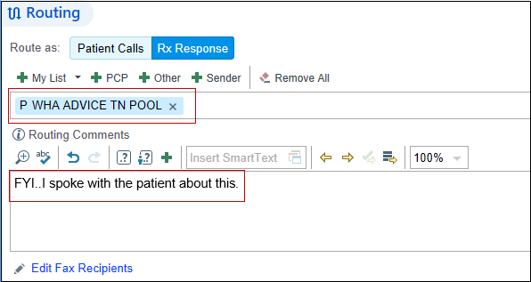
- Because no other work needs to be done with this encounter, click Sign Encounter.
  - If other work still needed to be done, you would click Send and Close Workspace so the encounter would be left unsigned, making it easier for other staff members to follow up and complete.

Exercise 6: Results Folder
Scenario: The look for the message in this folder that is for Gretchen who has had a Pap. The result came back abnormal, and you want the support to give her a call.
Notice the buttons above the message are specific to Result messages.
Remember you will want to turn off the Auto Advance setting, which needs to be done once for each type of folder.

- Click the Wrench above the list of messages.
- Unselect Turn Off Auto Advance. 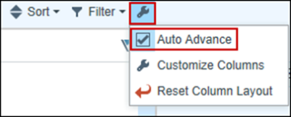

You can use the activity tabs at the top of the result to view the progress note, meds or problems. Take some time to do that now.
Let’s update the Pap Tracker for our Gretchen patient.

- Click on More Info.
- Scroll to the bottom of the pap result.
- Click on the PAP Smear with HPV - External blue hyper link that corresponds with the date of result.
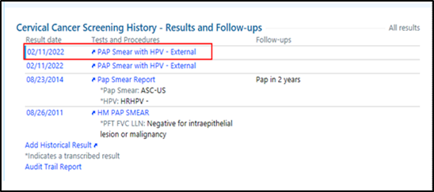
The Cervical Cancer Screening window opens. This is also called the Pap Tracker.

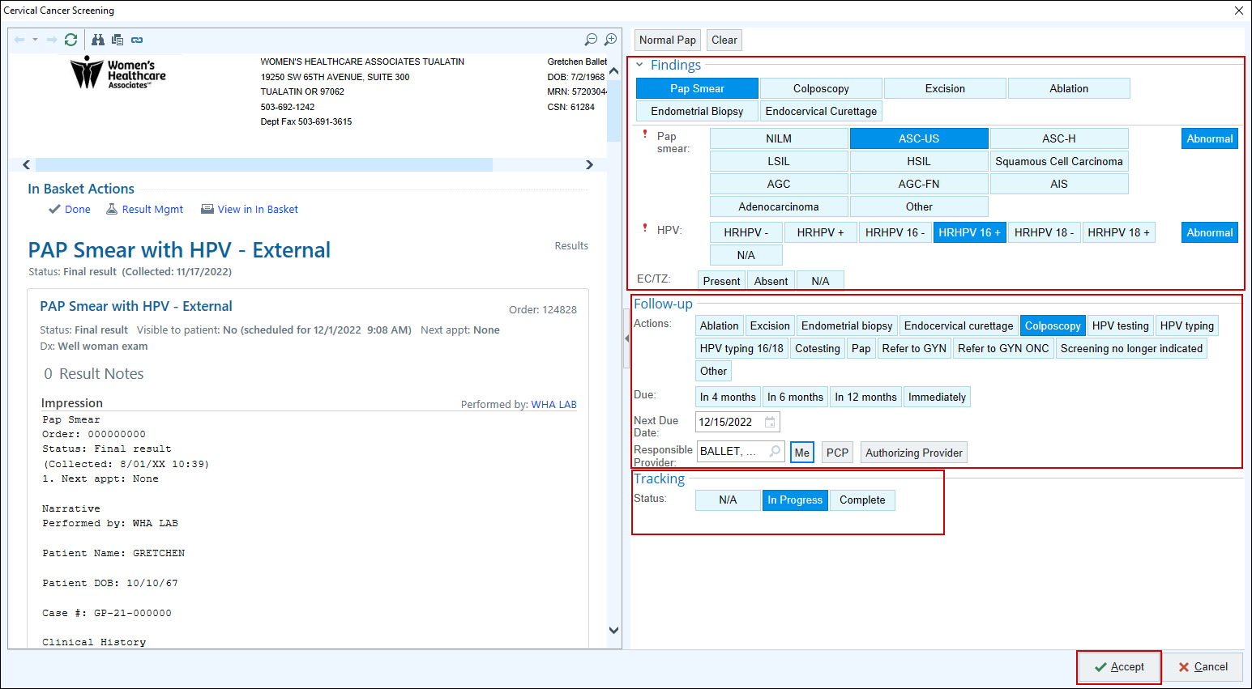

- Findings: ASCUS HPV 16 positive.
- Follow-up: Colpo in 4 weeks with you.
- Tracking: leave this as In-Progress.
- Click Accept.

You can now see your updated info.
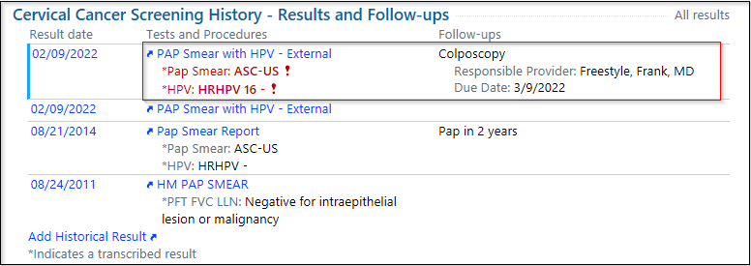
After reviewing; you want to send your MA a note to call the patient regarding this Abn result.
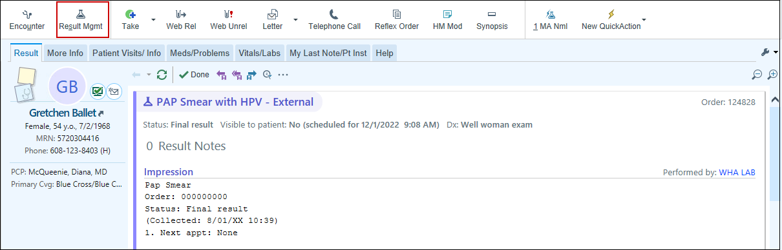
- Click the Result Mgmt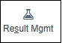.

The Result Note window opens.

- In the Route Note To section type P WHA POD 1 TN POOL

Also note the difference between Result Note section & MyHealth Comment.

- In the comment box of Result Note, type: .WHARNCOLPORNC
- In the MyHealth comment box, type: .WHARNCOLPOMHC

This would be a good time to create a QuickAction.
- Click on Save as QuickAction located at the top.
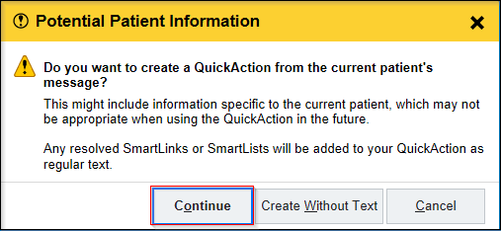
- Click Continue.
A QuickAction window opens.

- Name: Colpo
- Selected Results: Abnormal
- Route To: P WHA POD 1 TN POOL.
- Result Note/MyHealth: Replace patient name with .FNAME.
- Click Accept to save.
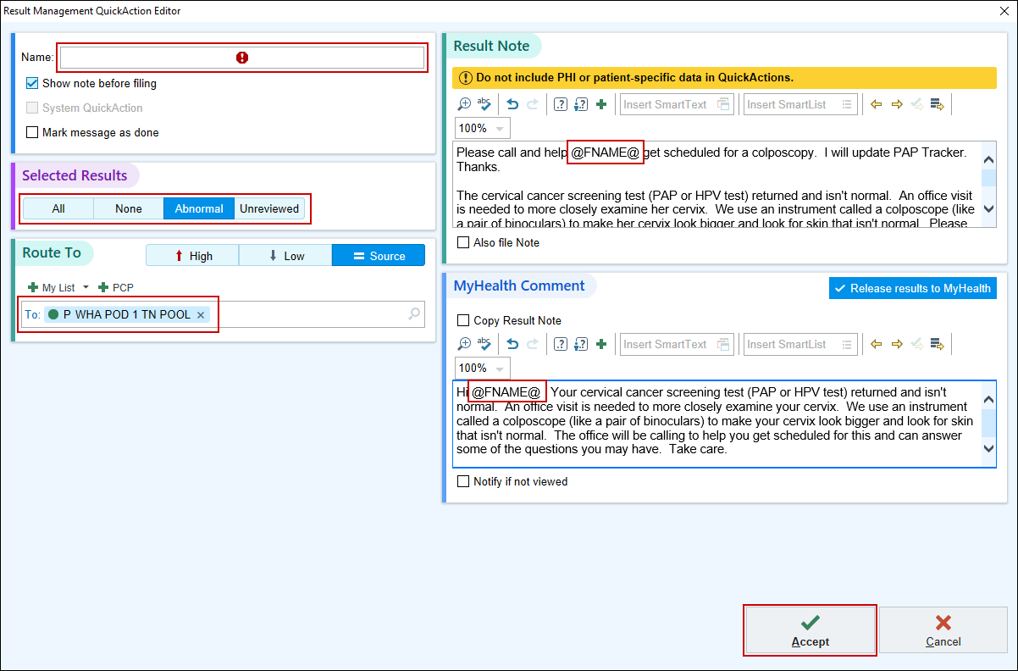
You have now created a rapid way to notify a patient of her abnormal PAP results if she is active in MyHealth. If a patient doesn’t have MyHealth, this still works.

- Back in the Result Management activity, click Accept to send the MyHealth Message and Result Note.
- Click the Done 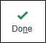 button.

Exercise 7: Results Folder

Scenario: The look for the message in this folder that is for Greta’s tissue path. The result came back and you want the support to give her a call.
Notice the buttons above the message are specific to Result messages.
Remember you will want to turn off the Auto Advance setting, which needs to be done once for each type of folder.

- Click the Wrench above the list of messages.
- Unselect Turn Off Auto Advance.

You can use the activity tabs at the top of the result to view the progress note, meds or problems. Take some time to do that now.
Let’s update the Pap Tracker for our Greta patient.

- Click on More Info.
- Scroll to the bottom of the pap result.
- Click on the Tissue Pathology hyper link that corresponds with the date of result.

The Cervical Cancer Screening window opens.
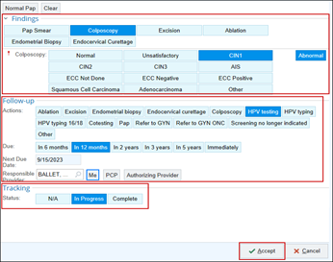
- Findings: Colposcopy; CIN1.
- Follow-up: Pap, HPV testing in 12 months with you.
- Tracking: leave this as In-Progress.
- Click Accept.

You can now see your updated info.

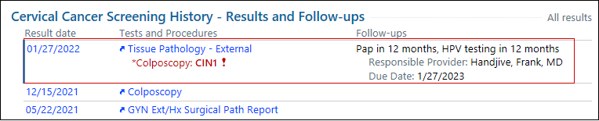
After reviewing; you want to send your MA a result note to call the patient regarding this Abn result.
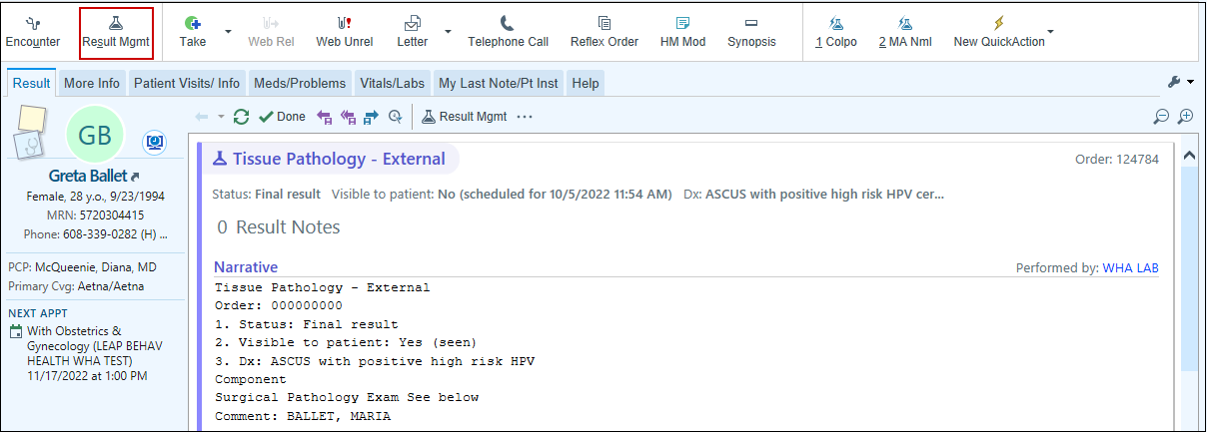
- Click the Result Mgmt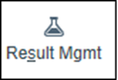.

The Result Note window opens.

- In the Route Note To section type P WHA POD 1 TN POOL

Also note the difference between Result Note section & MyHealth Comment because the patient does not have an active MyHealth account.

- In the Result Note comment box, use your clinical judgement and type a note to your support staff to notify patient of result.
- Click Accept.
- Click the Done button.

Exercise 8: Results Folder

You have another Result; this is for Camille’s Sequential Screen lab.
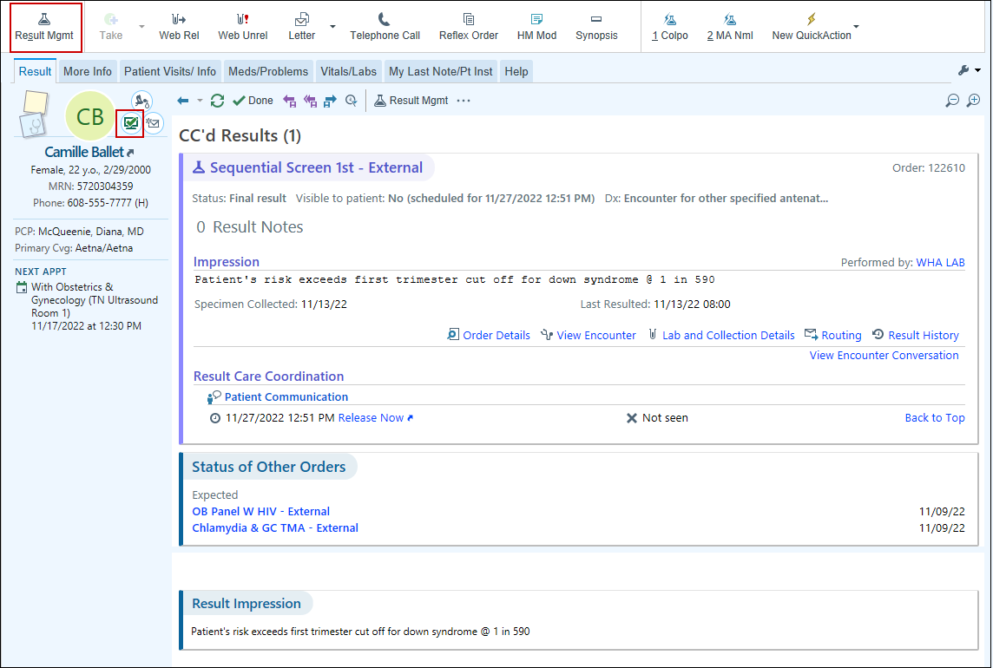
Note that her result is Negative and she is active in MyHealth.
- Notify the patient using your Result Mgmt.
- When complete, click Done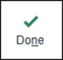.
- Click Refresh, the folder disappears.

Exercise 9: Respond to Patient Call

Scenario: Your MA informs you that she routed a call to you regarding you Camille patient. She is a new OB with a rash on her leg.

- Click the Patient Calls folder.
- Select your Camille patient.

The buttons above the message are specific for this type of communication.
Remember you will want to turn off the Auto Advance setting, which needs to be done once for each type of folder.

- Click the Wrench above the list of messages.
- Unselect Turn Off Auto Advance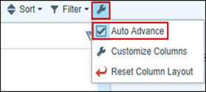.

You decide you want to call the patient back.
- Click the Encounter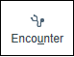 button.

Call Intake tab: 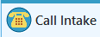

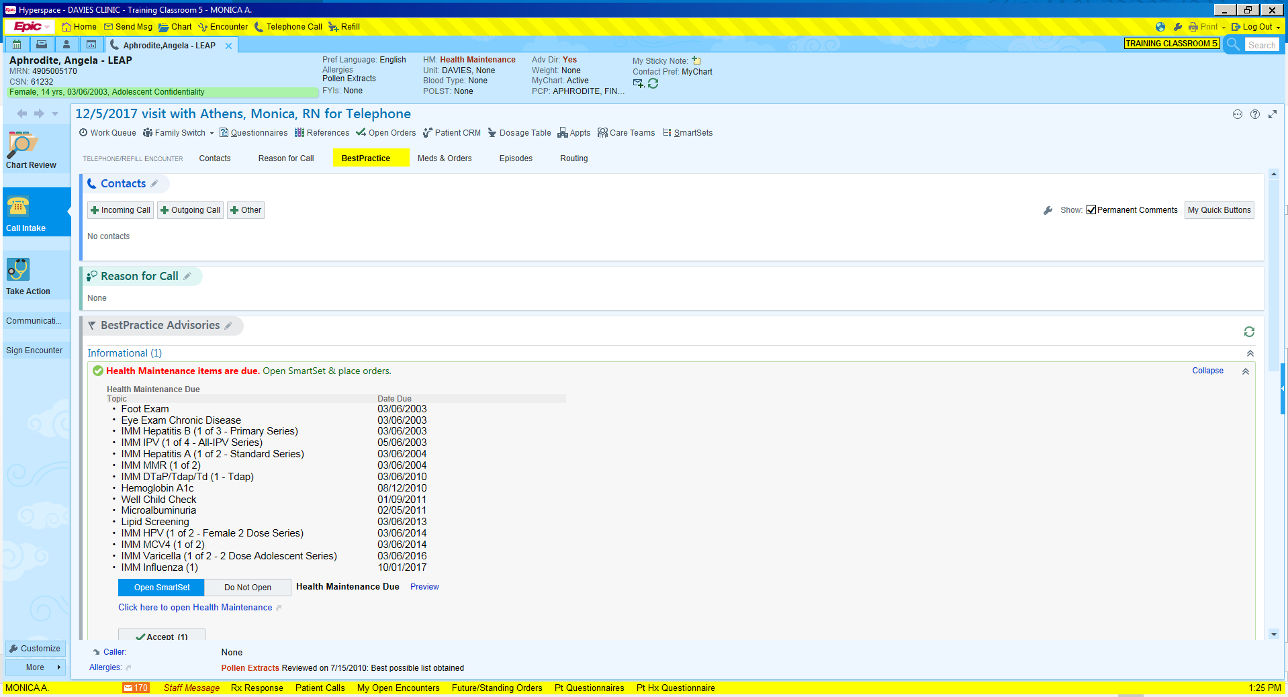
- Click the Outgoing Call button.
- You are speaking with the patient herself, Click the Self button.
- Calling from her Home #
- Click Accept.
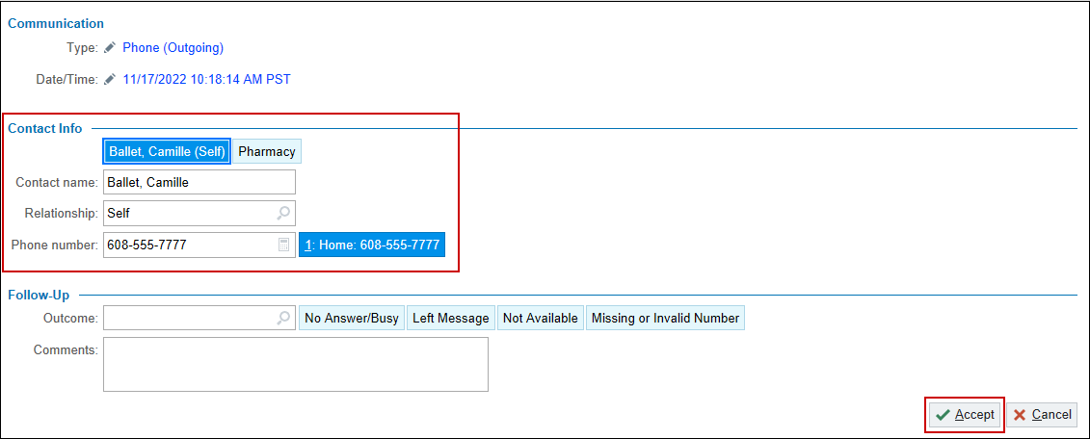

- In the Reason field, note it states Rash.
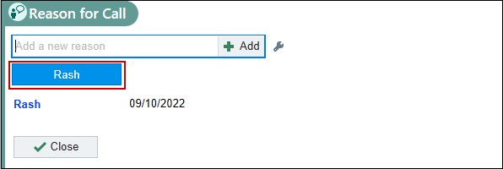
Now let’s document your conversation with the patient.

- Go to Documentation tab located on the right of your screen.
- Click into Create Note.
- Document using your clinical judgement.
- Click Accept when complete.
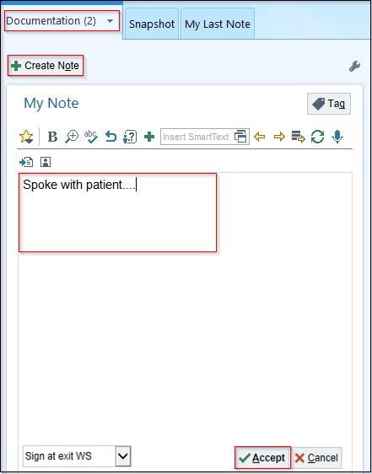
Do we need to Route this to anyone? NO
- Click Sign Encounter 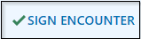.

The message is completed and will drop off the list.

Exercise 10: Respond to Patient Call

Scenario: Your Advice team has routed you a call regarding your patient Gabriella who is bleeding.

- Click the Patient Calls folder.
- Select your Gabriella patient.

The buttons above the message are specific for this type of communication.
You decide you want to respond to Advice vs calling the patient.
- Click the Note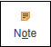 button.

*Information: For documentation that is more substantial, you can file it as a distinct note using the Note activity, so it is also available from the notes tab in Chart Review. You’ll typically want to use this option when your message includes an important clinical plan that you or others might want to refer to in the future.
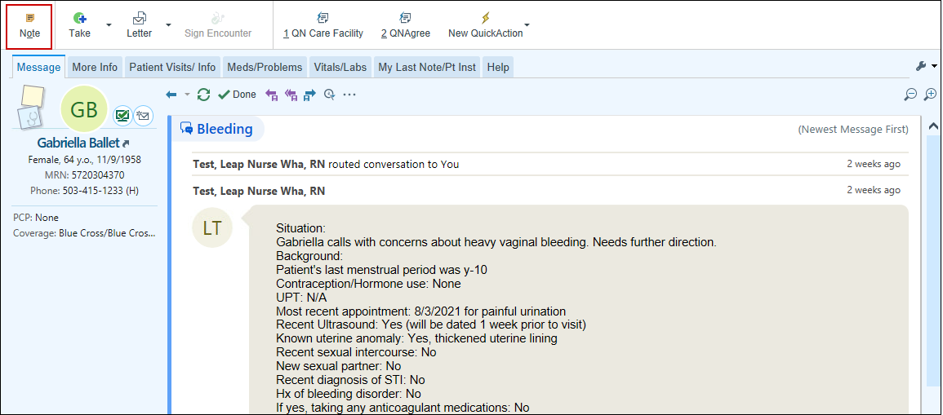
Now let’s fill in the fields of the Note.

- To: P WHA ADVICE TN POOL.
- My Note: Use your clinical judgement. Example: Please call patient and reassure her of the importance of keeping today’s appointment for biopsy. I will discuss at the time of visit her US results and next steps.
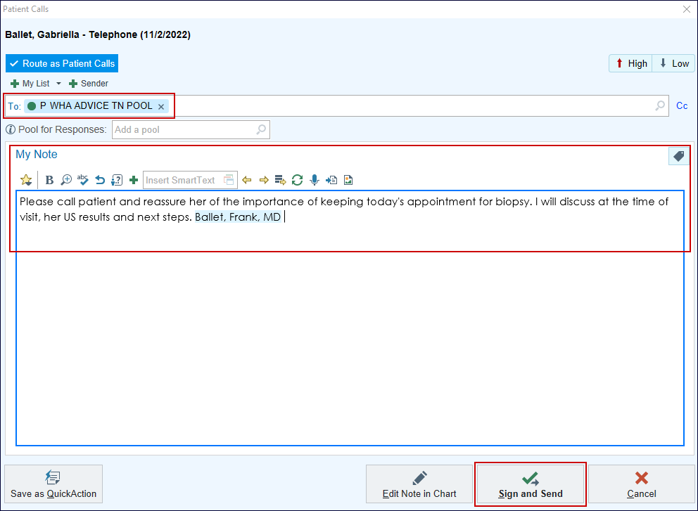
- Click Sign and Send 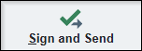.

The message is completed and will drop off the list.

Exercise 11: Attach to Another User’s In Basket

Scenario: This activity allows you to access the In Basket of other Epic users and grant other users access to your In Basket.

Clinicians typically attach to another user’s In Basket when covering for another WHA physician from their call group that is out of the office.
Before you can attach to another user’s In Basket, they must grant you access to it first.

To Grant Access:

- Go to your In Basket
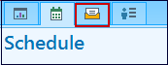
- Click Attach

This will open an activity box where you can Attach and Grant access to other users.
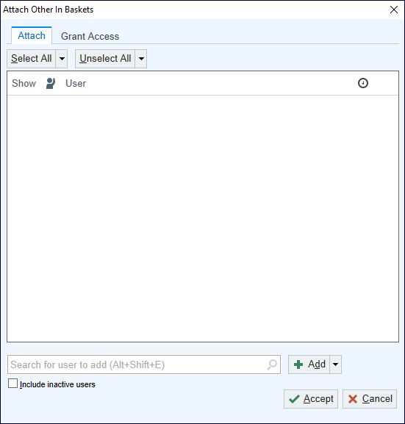
- Click the Grant Access tab.
- From the search box, enter the name of the user you’d like to grant access to.
- Click Grant.
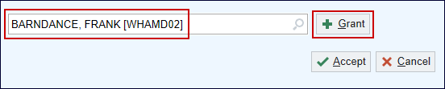
- Continue adding users to your list
- Click Accept

This grants access to other users to attach to your In Basket.
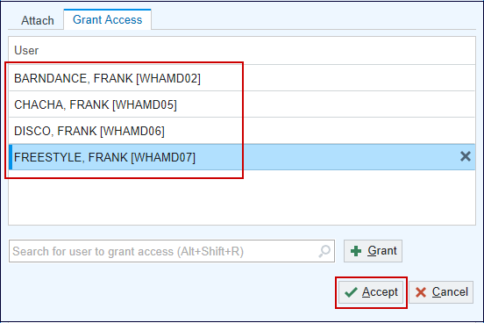

To Attach:
- From your In Basket, Click Attach
- This will open an activity box where you can Attach to other users InBasket.
Type in search box the user who you’re wanting to attach to.
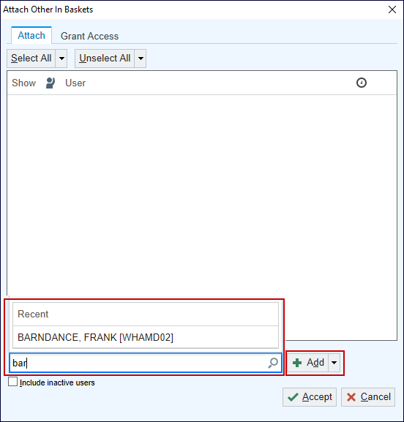
- Click Add 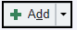

The user will populate into the box as you add them.
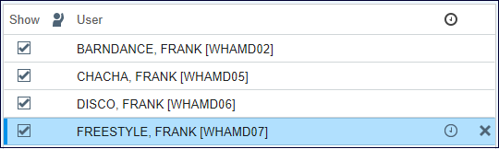
- Click Accept
On the Home activity, you can see the users InBaskets that you are attached to.
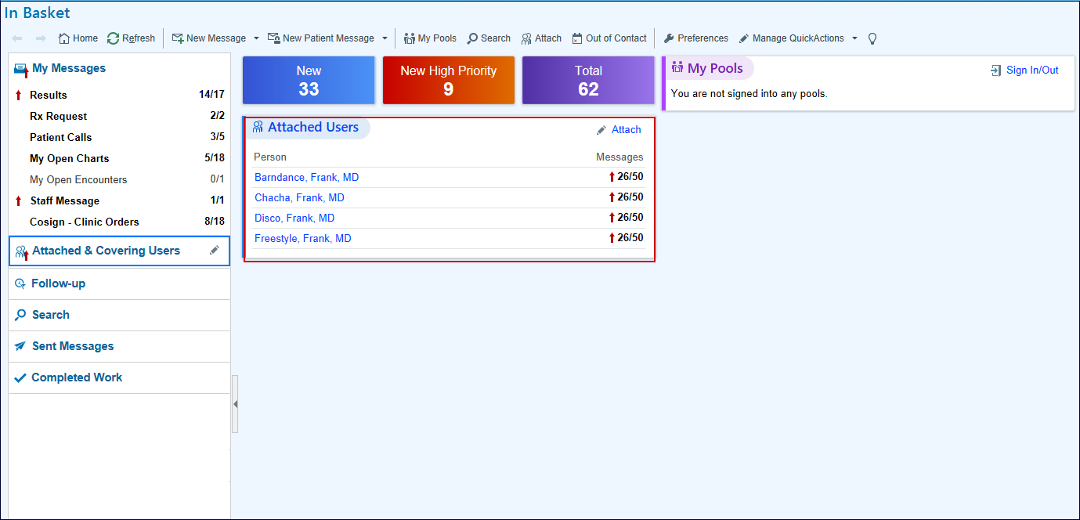
Click on a Clinician from your list to open their InBasket on the left of your screen under Attached & Covering Users.
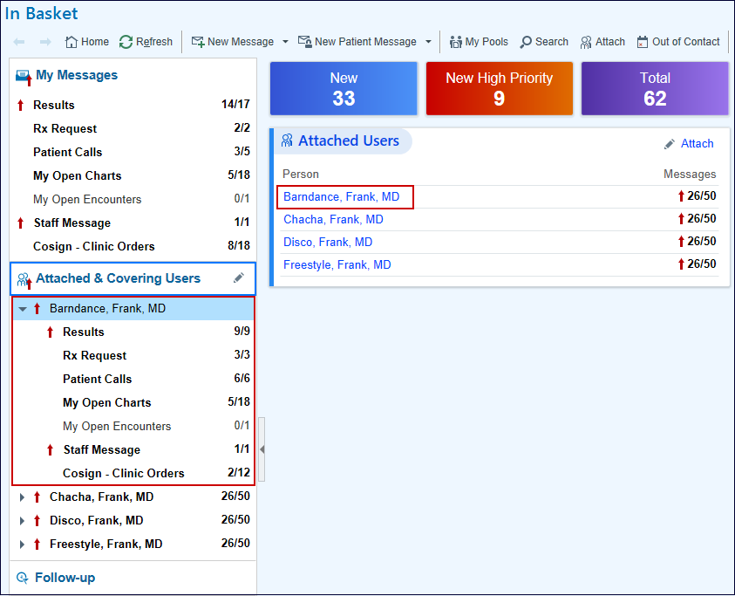

Module 8: Wrap Up

Q& A
Review Parking Lot questions and see if there are any other questions outstanding in class.

Where to find Legacy Resources
- Where to find Resources
    - Leap Trainers!
    - Legacy Online Resources- Home page> EPIC Support> (F1)
      - EHR Tip Sheets
      - EHR Support - 503-415-4750 on the far left in green box.

Tip sheets
The most up-to-date WHA standard workflow tip sheets can be accessed on SharePoint > Training > Clinician Specific.

